A Project report on

**Solving class imbalance problem using Random Sampling and advanced data augmentation techniques**

Submitted in partial fulfillment of the requirements for the award of the degree of

**MASTER OF TECHNOLOGY IN**

**Computer Science & Engineering**

By

**Anusha Kanukolanu**

**222020201001**

Under the Guidance of

**Dr. S PhaniKumar**

**Professor, HoD**





**Department of Computer Science School of Technology**

**Hyderabad**

**May, 2022**



**Department of Computer Science & Technology**

**CERTIFICATE**

This is to certify that the project report titled **Solving class imbalance problem sampling and advanced data augmentation techniques** is being submitted by K.Anusha, bearing **222020201001,** in M Tech IV semester *CSE* is a record bonafide work carried out by them. The results embodied in this report have not been submitted to any other University for the award of any degree.

Dr. S Phani Kumar Dr. S Phani Kumar

**Internal Guide External HoD**

**ACKNOWLEDGEMENT**

It is a great pleasure to have the opportunity to extend our heartfelt gratitude to everyone who helped us throughout the course of this project. We are profoundly grateful to our supervisor **Dr. Phani Kumar S**, Professor and HoD, GITAM School of Technology and Science for his expert guidance, continuous encouragement and ever willingness to spare time from his otherwise busy schedule for the project’s progress reviews. His continuous inspiration has made us complete this project and achieve its target.

We would also like to express our deepest appreciation to **Dr. Arif Mohammad Abdul,** Assistant Professor, Department of Computer Science and Information Technology, for his constant motivation, support and for providing us with a suitable working environment. We would also like to extend our sincere regards to all the faculty members for their support and encouragement.

At last our special thanks go to all staff members of the CSE department who directly and indirectly extended their hands in making this project a success.

**Contents Page No**

**Abstract 6-10**

List of Figures

List of Tables

1. **Introduction 11-13**
   1. Motivation
   2. Problem Definition
   3. Objective Of Project
   4. Scope and Applications
2. **Literature Survey 14-38**
   1. Literature Review
   2. Data collection
      1. Intel Scene Dataset
   3. Dataset Preparation
   4. Imbalance & Classification of Unbalanced datasets
   5. Traditional techniques for tackling class imbalanced data
   6. Data Augmentation Techniques for tackling Class Imbalance
   7. Background research about Deep Learning and RESNET18
3. **Tools Used 39-44** 
   1. Software Requirement Specification

3.1.1 Functional requirements

3.1.2 Non Functional Requirements

* 1. Feasibility Study
     1. Technical Feasibility
     2. Operational Feasibility
     3. Economic Feasibility
     4. Schedule Feasibility
  2. Software and Hardware Requirement
     1. Software Requirement
     2. Hardware Requirement

1. **PROJECT METHODOLOGY 45-48**
   1. System Design
   2. System Diagram
   3. Extensions made on the Existing Model
2. **MODEL ARCHITECTURE & SUMMARY 49-54**
   1. Model Architecture
   2. Model summary
3. **EXPERIMENTATION AND RESULTS 55-57**
4. **CONCLUSION AND RECOMMENDATION 58-59**
   1. Conclusion
   2. Future Scope
5. **BIBLIOGRAPHY 60-62**

**ABSTRACT**

**ABSTRACT**

Although state-of-the-art AI can produce incredible results in the lab, data scientists struggle to reproduce these results on real-world data. And it’s no surprise – real world data reflects the messy world that created it, containing all sorts of gaps and biases. One particularly painful feature of real-world data is that it can be imbalanced. An imbalanced dataset is a dataset where there are many more datapoints for one category than others. This research highlights the extensive study about solving class Imbalance problems using Random Sampling & Data Augmentation Techniques. The key aspect highlighted is to understand how Under-Sampling, Over-Sampling, Synthetic Minority Over-sampling Technique & Data Augmentation using Image and custom datasets. The model performance is being improved with the removal of class imbalance problem using various Augmentation approaches using an augmentation library. The accuracies are compared to solve the Class imbalance problem to maximize accuracy and reduce error & find the best possible method to solve it.

**FIGURES**

|  |  |  |
| --- | --- | --- |
| **Figure No.** | **Figure Name** | **Page** |
| 1 | Cost Matrix | 20 |
| 2 | Data Augmentation Techniques | 22 |
| 3 | Image Classification | 23 |
| 4 | Classification and Localization | 24 |
| 5 | Object Detection | 25 |
| 6 | Semantic Segmentation | 25 |
| 7 | Instance Segmentation | 26 |
| 8 | Difference between object detection, semantic and instance segmentation | 26 |
| 9 | Artificial Neural Network with input, hidden and output layers | 27 |
| 10 | Hidden Layers | 27 |
| 11 | Chain Rule | 28 |
| 12 | Dimension of image | 29 |
| 13 | Convolution process | 29 |
| 14 | DCG Multiplication for two numbers | 30 |
| 15 | Skip Connection | 33 |
| 16 | ResNet-18 Architecture | 34 |
| 17 | Building Blocks | 34 |
| 18 | ResNet-18 Layers | 35 |
| 19 | Identify Block | 36 |
| 20 | Convolutional Block | 36 |
| 21 | Convolutional Operation | 36 |
| 22 | Pooling Operation | 37 |
| 23 | NLL Loss Function | 38 |
| 24 | Difference b/w OpenCV and PIL | 41 |
| 25 | System Diagram | 46 |
| 26 | ResNet-18 Architecture | 50 |
| 27 | Building Blocks of ResNet 18 | 50 |
| 28 | ResNet-18 Layers | 51 |

**TABLES**

|  |  |  |
| --- | --- | --- |
| **Table No.** | **Table Name** | **Page** |
| Table 1 | Literature Survey | 15 |
| Table 2 | DataSets | 16 |
| Table 3 | Effective & Non Effective Augmentations for Intel Scene Dataset | 56 |
| Table 4 | Variation of Augmentations with imbalance ratio for Intel Scene Dataset | 57 |

**INTRODUCTION**

**1 INTRODUCTION**

* 1. **MOTIVATION**

There are many augmentations supported by various augmentation libraries that help in improvement of the accuracies of the various models. To find the best augmentation technique based on accuracy using a model by building an augmentation library/ package/module which will generate an augmented balanced dataset, in-turn, solving the Class imbalance problem.

* 1. **PROBLEM DEFINITION**

Improving model performance & removing the class imbalance problem using various Augmentation approaches for an intel scenery dataset & a Custom Augmentation library.

* 1. **OBJECTIVE OF THE PROJECT**

Following are the objectives –

To find the best Data augmentation technique for the dataset based on the accuracies for the augmented datasets with balancing of unbalanced dataset

* 1. **SCOPE AND APPLICATIONS**

The scope of this system is to tackle the problems that can arise in day-to-day life in artificial intelligence. Some of the scopes are:

* + 1. The system can be used to balance an unbalanced dataset using various augmentation techniques and to improve the accuracy of the model.
    2. It can be applied to any data set which has a an imbalance in the number of examples in the classes.
    3. This can be used in various driverless cars technology are else any kind of automation which includes artificial intelligence.
    4. Imbalance can be present in any data set or application, and hence, the practitioner should be aware of the implications of modeling this type of data.
    5. It can be used to train the deep learning model much more efficiently with a small amount of data.
    6. This saves us time and resources for finding more data
    7. The imbalance in the class distribution may vary, but a severe imbalance is more challenging to model and may require specialized techniques.
    8. Many real-world classification problems have an imbalanced class distribution, such as fraud detection, spam detection, and churn prediction.
    9. Imbalanced learning not only presents significant new challenges to the data research community but also raises many critical questions in real-world data- intensive applications, ranging from civilian applications such as financial and biomedical data analysis to security- and defense-related applications such as surveillance and military data analysis.
    10. Many classification problems may have a severe imbalance in the class distribution; nevertheless, looking at common problem domains that are inherently imbalanced will make the ideas and challenges of class imbalance concrete.
        - Fraud Detection.
        - Claim Prediction
        - Default Prediction.
        - Churn Prediction.
        - Spam Detection.
        - Anomaly Detection.
        - Outlier Detection.
        - Intrusion Detection
        - Conversion Prediction
    11. Each of these problem domains represents an entire field of study, where specific problems from each domain can be framed and explored as imbalanced classification predictive modeling. This highlights the multidisciplinary nature of class imbalanced classification, and why it is so important for a machine learning practitioner to be aware of the problem and skilled in addressing it.

**LITERATURE SURVEY**

**2. LITERATURE SURVEY**

**2.1. Data collection**

The public databases to evaluate the algorithms are:

**2.1.1. Intel Scenery Dataset**

This is image data of Natural Scenes around the world. This Data contains around 25k images of size 150x150 distributed under 6 categories. Out of which 2 classes were selected, which are -

* 'buildings' – Class 0
* 'sea' – Class 1

Train set 2000 images per class. Test set 400 images per class.

**2.2. Dataset Preparation**

**2.2.1 Intel Scenery Dataset**

The proposed system was trained and tested using datasets namely Intel Scene Dataset. This is image data of Natural Scenes around the world. This Data contains around 25k images of size 150x150 distributed under 6 categories.

For our experiment we have used 2 classes with the following number of examples in each class

Training sets

A. BALANCED (1:1)

1. A = 2000 ; B = 2000

B. SLIGHT IMBALANCE (<=1:10) -

1. A = 2000 ; B = 1000
2. A = 2000 ; B = 500
3. A = 2000 ; B = 250

C. SEVERE IMBALANCE (>1:10) -

1. A = 2000 ; B = 125
2. A = 2000 ; B = 100

CLASS A = buildings

CLASS B = sea

The test set has 400 images in each of the 2 classes - buildings & sea

We normalized the faces to 72 pixels. Based on the structure of images of 150*150 pixels original images were resized to 224*224.

After resizing the images to 224*224, We are converting the images into tensor & normalizing them with mean= [0.485, 0.456, 0.406] and standard deviation, std= [0.229, 0.224, 0.225] respectively

We are loading the data into the data loader & passing them through the model which is a residual network RESNET18.

**2.3. Imbalance & Classification of Unbalanced datasets**

Machine learning is a branch of artificial intelligence, which is concerned with the construction and study of systems that can learn from data. There are three approaches in the machine learning model i.e. supervised learning, semi-supervised learning and unsupervised learning. For example, a deep learning model could be trained on images to learn to distinguish between pedestrian and non- pedestrian images. After learning, it can then be used to classify new images into pedestrian and non-pedestrian folders.

**Key Terminologies -**

**Classification** - Classification predictive modeling involves predicting a class label for a given observation.

**Imbalanced Classification -** A classification predictive modeling problem where the distribution of examples across the classes is not equal.

**Majority Class -** The class (or classes) in an imbalanced classification predictive modeling problem that has many examples.

**Minority Class -** The class in an imbalanced classification predictive modeling problem that has few examples.

**Imbalanced classification problem** - An imbalanced classification problem is an example of a classification problem where the distribution of examples across the known classes is biased or skewed. The distribution can vary from a slight bias to a severe imbalance where there is one example in the minority class for hundreds, thousands, or millions of examples in the majority class or classes. Imbalanced classification is the problem of classification when there is an unequal distribution of classes in the training dataset. This results in models that have poor predictive performance, specifically for the minority class. This is a problem because typically, the minority class is more important and therefore the problem is more sensitive to classification errors for the minority class than the majority class.

**Binary Classification Problem -** A classification predictive modeling problem where all examples belong to one of two classes.

**Multiclass Classification Problem -** A classification predictive modeling problem where all examples belong to one of three classes.

**Training Dataset -** A number of examples collected from the problem domain that include the input observations and output class labels. Depending on the complexity of the problem and the types of models we may choose to use, we may need tens, hundreds, thousands, or even millions of examples from the domain to constitute a training dataset.

**Causes of Class Imbalance -** There are perhaps two main groups of causes for the imbalance we may want to consider; they are data sampling and properties of the domain. It is possible that the imbalance in the examples across the classes was caused by the way the examples were collected or sampled from the problem domain. This might involve biases introduced during data collection, and errors made during data collection.

* Biased Sampling.
* Measurement Errors.

**Slight Imbalance -** An imbalanced classification problem where the distribution of examples is uneven by a small amount in the training dataset (e.g. 4:6).

**Severe Imbalance -** An imbalanced classification problem where the distribution of examples is uneven by a large amount in the training dataset (e.g. 1:100 or more).

**Overfitting -** Good performance on the training data, poor generalization to other data. Over-fitting, characterized by high variance, occurs when a model fits too closely to the training data and is then unable to generalize to new data. A variety of intelligent sampling methods have been developed in an attempt to balance these trade-offs.

**Underfitting -** Poor performance on the training data and poor generalization to other data.

**2.4. Traditional techniques for tackling class imbalanced data**

Addressing class imbalance with traditional machine learning techniques has been studied extensively over the last two decades. The bias towards the majority class can be alleviated by altering the training data to decrease imbalance, or by modifying the model’s underlying learning or decision process to increase sensitivity towards the minority group.

As such, methods for handling class imbalance are grouped into data-level techniques, algorithm-level methods, and hybrid approaches. This section summarizes some of the more popular traditional machine learning methods for handling class imbalance.

**Data-level methods -** Data-level methods for addressing class imbalance include

* **random over-sampling -** random over-sampling (ROS) duplicates random samples from the minority group. Over-sampling will cause an increased training time due to the increased size of the training set, and has also been shown to cause over-fitting.
* **random under-sampling -** random under-sampling (RUS) discards random samples from the majority group, Under-sampling voluntarily discards data, reducing the total amount of information the model has to learn from.

These techniques modify the training distributions in order to decrease the level of imbalance or reduce noise, e.g. mislabeled samples or anomalies.

**Intelligent under-sampling methods -** It aims to preserve valuable information for learning.

* **Near-Miss algorithms -** There are several Near-Miss algorithms that use a K-nearest neighbors (K-NN) classifier to select majority samples for removal based on their distance from minority samples.
* **One-sided selection -** It was proposed by Kubat and Matwin as a method for removing noisy and redundant samples from the majority class as they are discovered through a 1-NN rule and Tomek links. It uses Wilson’s editing, a K-NN rule that removes misclassified samples from the training set, to remove majority samples from class boundaries.

**Over-sampling techniques** - A number of informed over-sampling techniques have also been developed to strengthen class boundaries, reduce over-fitting, and improve discrimination.

* **Synthetic Minority Over-sampling Technique (SMOTE) -** It is a method that produces artificial minority samples by interpolating between existing minority samples and their nearest minority neighbors. Several variants to SMOTE, e.g. Borderline-SMOTE and Safe-Level-SMOTE, improve upon the original algorithm by also taking majority class neighbors into consideration.
* **Borderline-SMOTE -** Itlimits over-sampling to the samples near class borders.
* **Safe-Level-SMOTE -** It defines safe regions to prevent over-sampling in overlapping or noise regions.

**Supervised learning systems** - Supervised learning systems usually define a concept with several disjuncts, where each disjunct is a conjunctive definition describing a subconcept [47]. The size of a disjunct corresponds to the number of samples that the disjunct correctly classifies. Small disjuncts, often corresponding to rare cases in the domain, are learned concepts that correctly classify only a few data samples. These small disjuncts are problematic, as they often contain much higher error rates than large disjuncts, and they cannot be removed without compromising performance [48].

**Cluster-based over-sampling -** It is used to address the presence of small disjuncts in the training data. Minority and majority groups are first clustered using the K-means algorithm, then over-sampling is applied to each cluster separately. This improves both within-class imbalance and between-class imbalance.

**Extensive Experiments by Van Hulse et al. -** He compared seven different sampling techniques with 11 commonly-used machine learning algorithms. Each model was evaluated with 35 benchmark data sets using six different performance metrics to compare results.

* It was shown that sampling results were highly dependent on both the learner and the evaluation performance metric.
* Experiments revealed that RUS resulted in good performance overall, outperforming ROS and intelligent sampling methods in most cases. The results suggest that, although RUS performs well in most cases
* No sampling method is guaranteed to perform best in all problem domains, and multiple performance metrics should be used when evaluating results.

**Algorithm-level methods -** Unlike data sampling methods, algorithmic methods for handling class imbalance do not alter the training data distribution. Instead, the learning or decision process is adjusted in a way that increases the importance of the positive class. Most commonly, algorithms are modified to take a class penalty or weight into consideration, or the decision threshold is shifted in a way that reduces bias towards the negative class.

* **Cost-sensitive learning** - In cost-sensitive learning, penalties are assigned to each class through a cost matrix. Increasing the cost of the minority group is equivalent to increasing its importance, decreasing the likelihood that the learner will incorrectly classify instances from this group. The cost matrix of a binary classification problem is shown in Figure2. A given entry of the table, cij, is the cost associated with predicting class i when the true class is j. Usually, the diagonal of the cost matrix, where i=j, is set to 0. The costs corresponding to false positive and false negative errors are then adjusted for desired results.  
    
  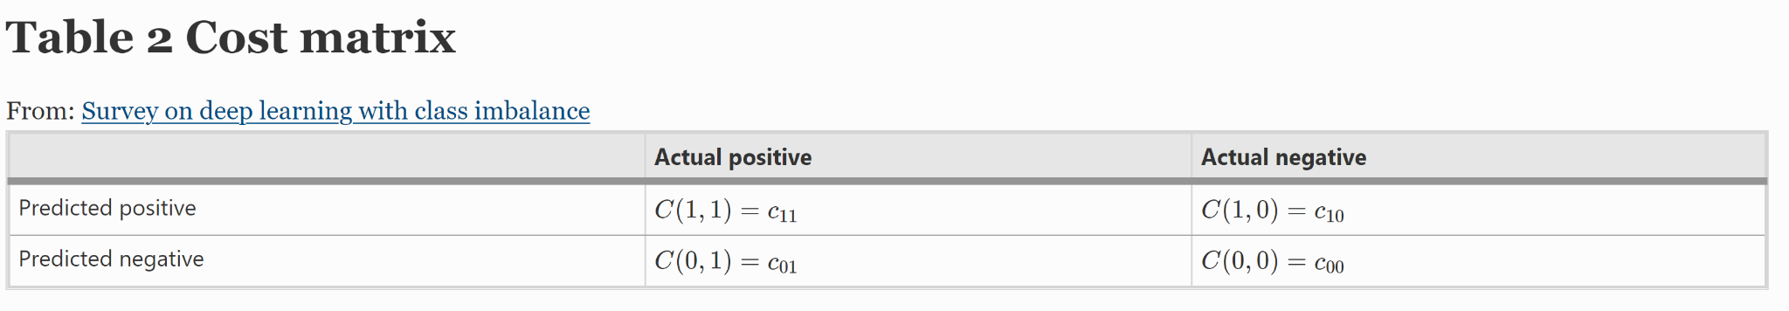

figure 1 cost matrix

Ling and Sheng categorize cost-sensitive methods as either a direct method, or a meta-learning method.

* Direct methods are methods that have cost-sensitive capabilities within themselves, achieved through modification of the learner’s underlying algorithm such that costs are taken into consideration during learning. The optimization process changes from one of minimizing total error, to one of minimizing total cost.
* Meta-learning methods utilize a wrapper to convert cost-insensitive learners into cost-sensitive systems. If a cost-insensitive classifier produces posterior probability estimates, the cost matrix can be used to define a new threshold p∗ such that:

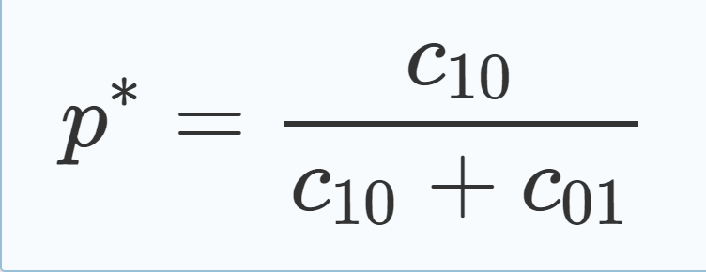

* Usually, thresholding methods use p∗ (above figure) to redefine the output decision threshold when classifying samples. Threshold moving, or post-processing the output class probabilities using Eq. 10, is one meta-learning approach that converts a cost-insensitive learner into a cost-sensitive system.
* One of the biggest challenges in cost-sensitive learning is the assignment of an effective cost matrix. The cost matrix can be defined empirically, based on past experiences, or a domain expert with knowledge of the problem can define them. Alternatively, the false negative cost can be set to a fixed value while the false positive cost is varied, using a validation set to identify the ideal cost matrix. The latter has the advantage of exploring a range of costs, but can be expensive and even impractical if the size of the data set or number of features is too large.

**Hybrid methods -** Data-level and algorithm-level methods have been combined in various ways and applied to class imbalance problems.

One strategy includes performing data sampling to reduce class noise and imbalance, and then applying cost-sensitive learning or thresholding to further reduce the bias towards the majority group.

Several techniques which combine ensemble methods with sampling and cost-sensitive learning were presented. Liu et al. proposed two algorithms -

* EasyEnsemble
* BalanceCascade

These 2 learn multiple classifiers by combining subsets of the majority group with the minority group, creating pseudo-balanced training sets for each individual classifier.

* SMOTEBoost
* DataBoost-IM
* JOUS-Boost

all combine sampling with ensembles.

Sun [56] introduced three cost-sensitive boosting methods -

* AdaC1
* AdaC2
* AdaC3

These methods iteratively increase the impact of the minority group by introducing cost items into the AdaBoost algorithm’s weight updates. Sun showed that the cost-sensitive boosted ensembles outperformed plain boosting methods in most cases.

**2.6 Data Augmentation Techniques for tackling Class Imbalance:**

Data augmentation is a technique to artificially create new training data from existing training data. Data augmentation is a strategy that enables to significantly increase the diversity of data available for training models, without actually collecting new data.

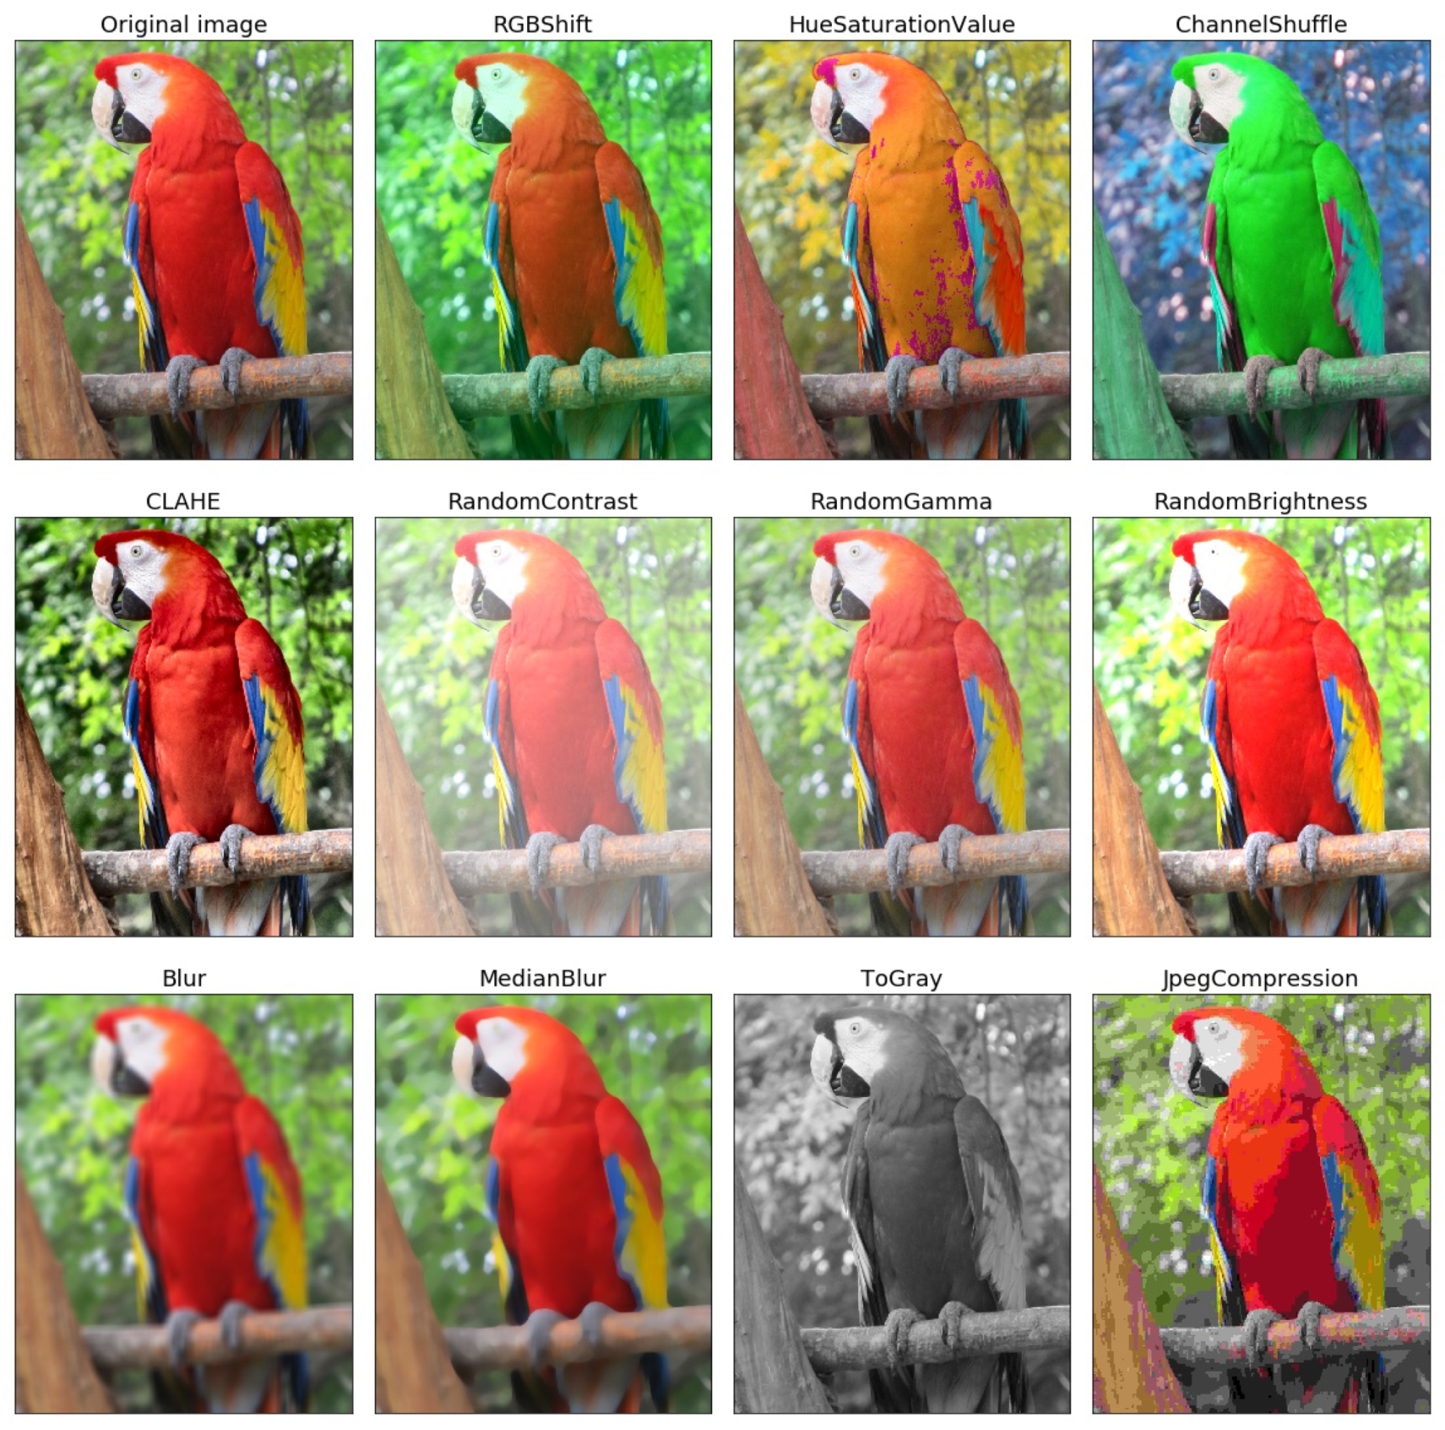

figure. 2 Data Augmentation Techniques

**2.7 Background research about Deep Learning and RESNET18:**

**Computer vision -** Computer vision is an interdisciplinary scientific field that deals with how computers can be made to gain high-level understanding from digital images or videos. From the perspective of engineering, it seeks to automate tasks that the human visual system can do.

Deep Learning has enabled the field of Computer Vision to advance rapidly in the last few years. In this post I would like to discuss one specific task in Computer Vision called Semantic Segmentation. Even though researchers have come up with numerous ways to solve this problem, I will talk about a particular architecture namely UNET, which use a Fully Convolutional Network Model for the task.

We will use UNET to build a first-cut solution to the TGS Salt Identification challenge hosted by Kaggle.

Along with this, my purpose of writing the blog is to also provide some intuitive insights on the commonly used operations and terms in Convolutional Networks for Image understanding. Some of these include Convolution, Max Pooling, Receptive field, Up-sampling, Transposed Convolution, Skip Connections, etc.

There are various levels of granularity in which the computers can gain an understanding of images. For each of these levels there is a problem defined in the Computer Vision domain. Starting from a coarse grained down to a more fine grained understanding, let’s describe these problems below:

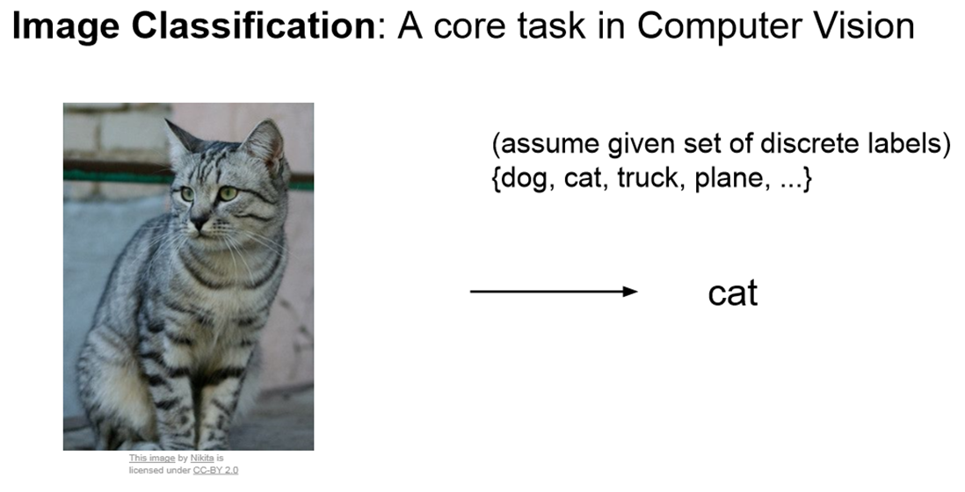

figure. 3 Image Classification

a. Image classification

The most fundamental building block in Computer Vision is the Image classification problem where given an image, we expect the computer to output a discrete label, which is the main object in the image. In image classification we assume that there is only one (and not multiple) object in the image.

b. Classification with Localization

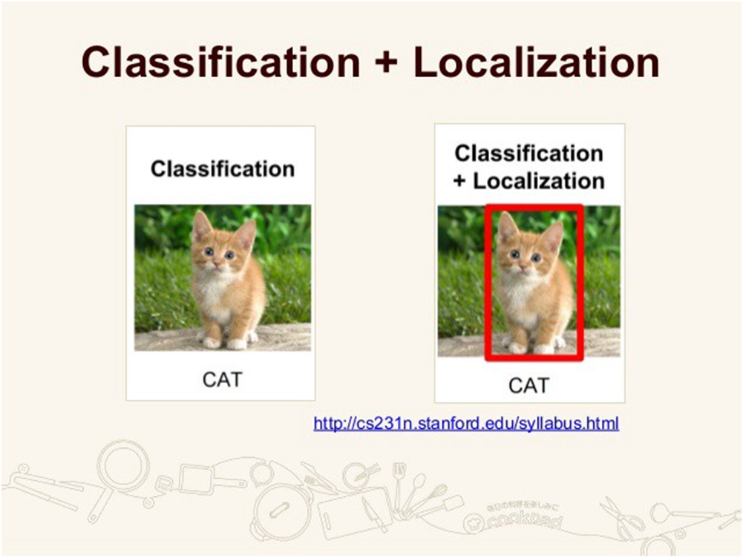

figure.4 Classification and Localization

In localization along with the discrete label, we also expect the compute to localize where exactly the object is present in the image. This localization is typically implemented using a bounding box which can be identified by some numerical parameters with respect to the image boundary. Even in this case, the assumption is to have only one object per image.

c. Object Detection

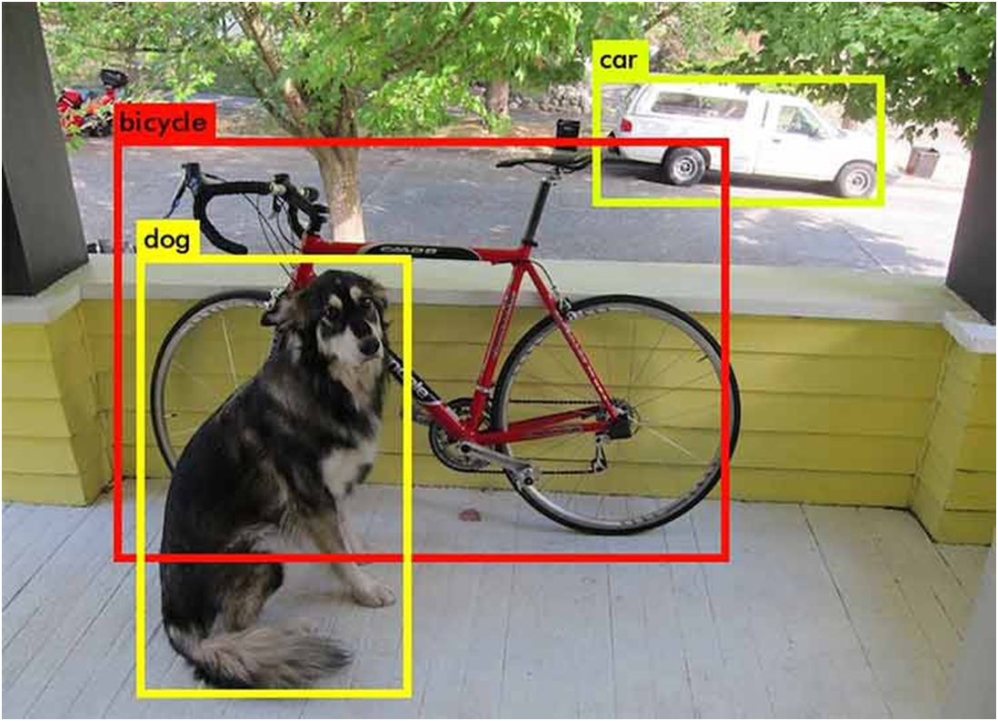

figure.5 Object Detection

Object Detection extends localization to the next level where now the image is not constrained to have only one object, but can contain multiple objects. The task is to classify and localize all the objects in the image. Here again the localization is done using the concept of bounding box.

d. Semantic Segmentation

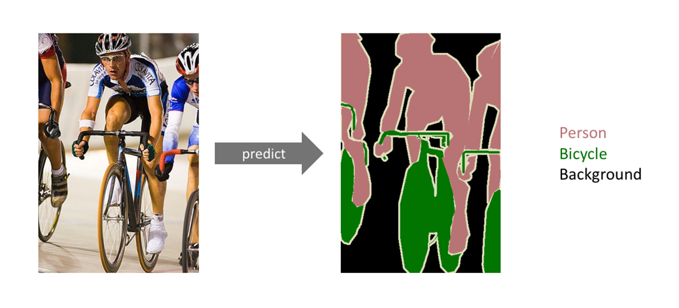

figure.6 Semantic Segmentation

The goal of semantic image segmentation is to label each pixel of an image with a corresponding class of what is being represented. Because we’re predicting for every pixel in the image, this task is commonly referred to as dense prediction.

Note that unlike the previous tasks, the expected output in semantic segmentation are not just labels and bounding box parameters. The output itself is a high resolution image (typically of the same size as input image) in which each pixel is classified to a particular class. Thus it is a pixel level image classification.

e. Instance segmentation

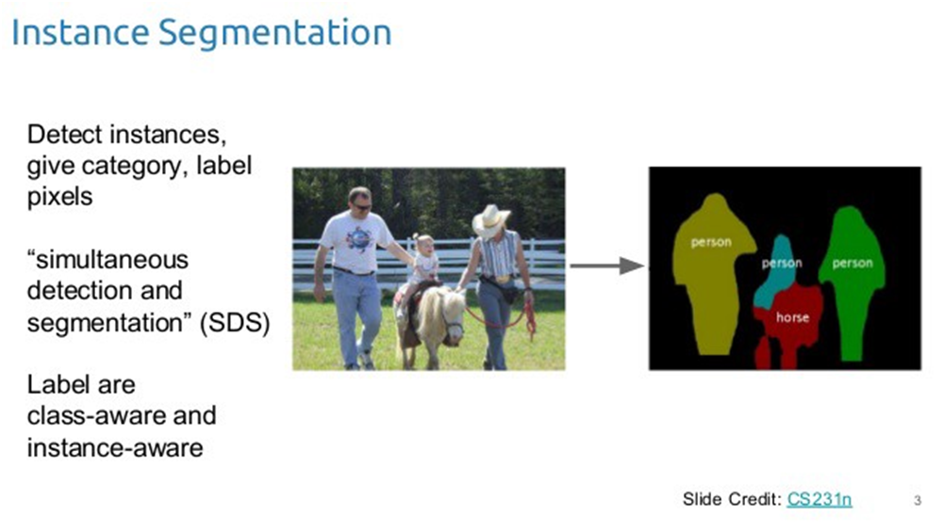

figure.7 Instance Segmentation

Instance segmentation is one step ahead of semantic segmentation wherein along with pixel level classification, we expect the computer to classify each instance of a class separately. For example in the image above there are 3 people, technically 3 instances of the class “Person”. All the 3 are classified separately (in a different color). But semantic segmentation does not differentiate between the instances of a particular class.

If you are still confused between the differences of object detection, semantic segmentation and instance segmentation, below image will help to clarify the point:

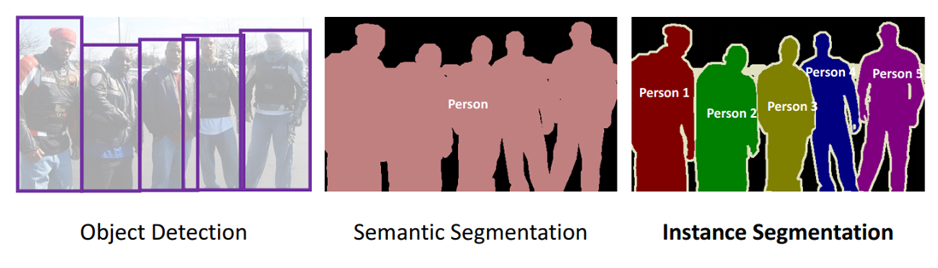

figure.8 Difference between object detection, semantic and instance segmentation

**Structure of the Neural Network -**  The network we have talked about so far must have a structure or model that would help all the learning and computational processes.A model that has multiple layers of neurons or nodes. MLP neural network learned by back propagation algorithm is based on supervised procedure, i.e. the network constructs a model based on examples of data with known output. As like 23 | P a g e any network models this network also contains two basic layers called input layer and output layer. The number

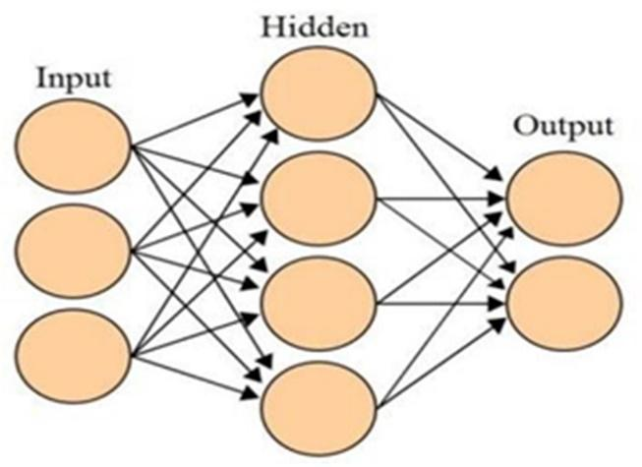

**Figure :9 Artificial Neural Network with input, hidden and output layers**

of neurons in the input layer depends on the input image size that is each pixel represents each node respectively. The output layer may contain one or more neurons depending on the developer and the system. In our system we kept 4 output neurons which will resembles emotions such as HAPPY, NEUTRAL, SAD and SURPRISED. In between these two layers there may be one or more additional layers called the hidden layers. We have added one hidden layer in our system because it increases accuracy while the learning process proceeds. There is no fixed rule for the number of neurons that would be in the hidden layer.

These bunches of layers are interconnected and as part of MLP the information flows unidirectional from input layer to output layer through hidden layer. In each node there are assigned weight depending on the node type. An idealization of a NEURON processes activities or signals. Each input activity is multiplied by a number called weight. The unit adds together the weighted inputs. Then it computes the output activity using an input- output function.

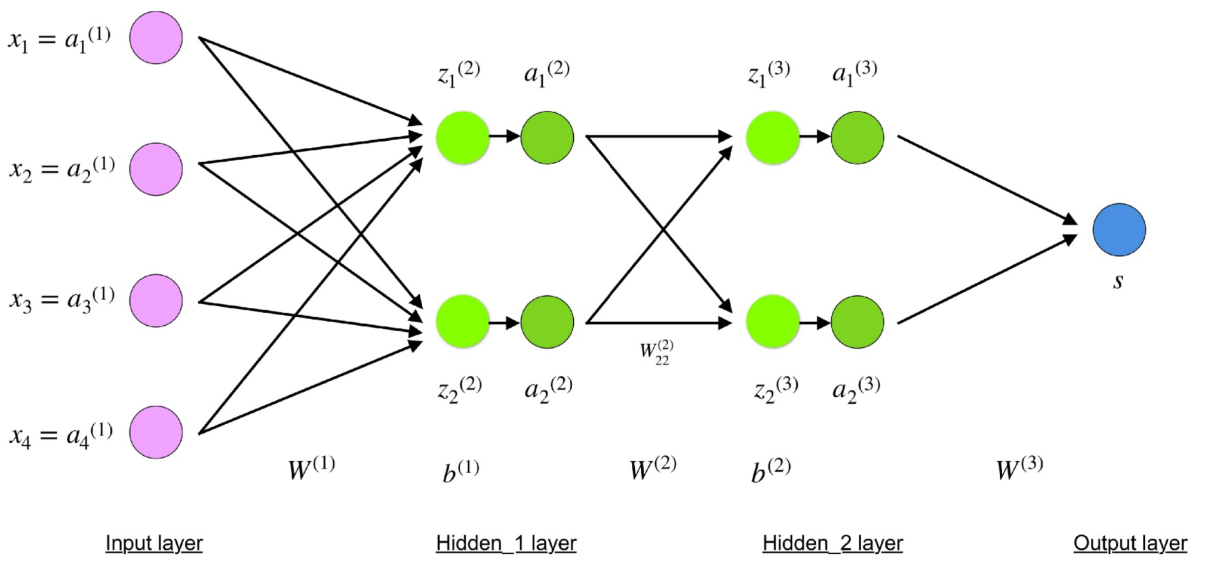

figure.10 Hidden Layers

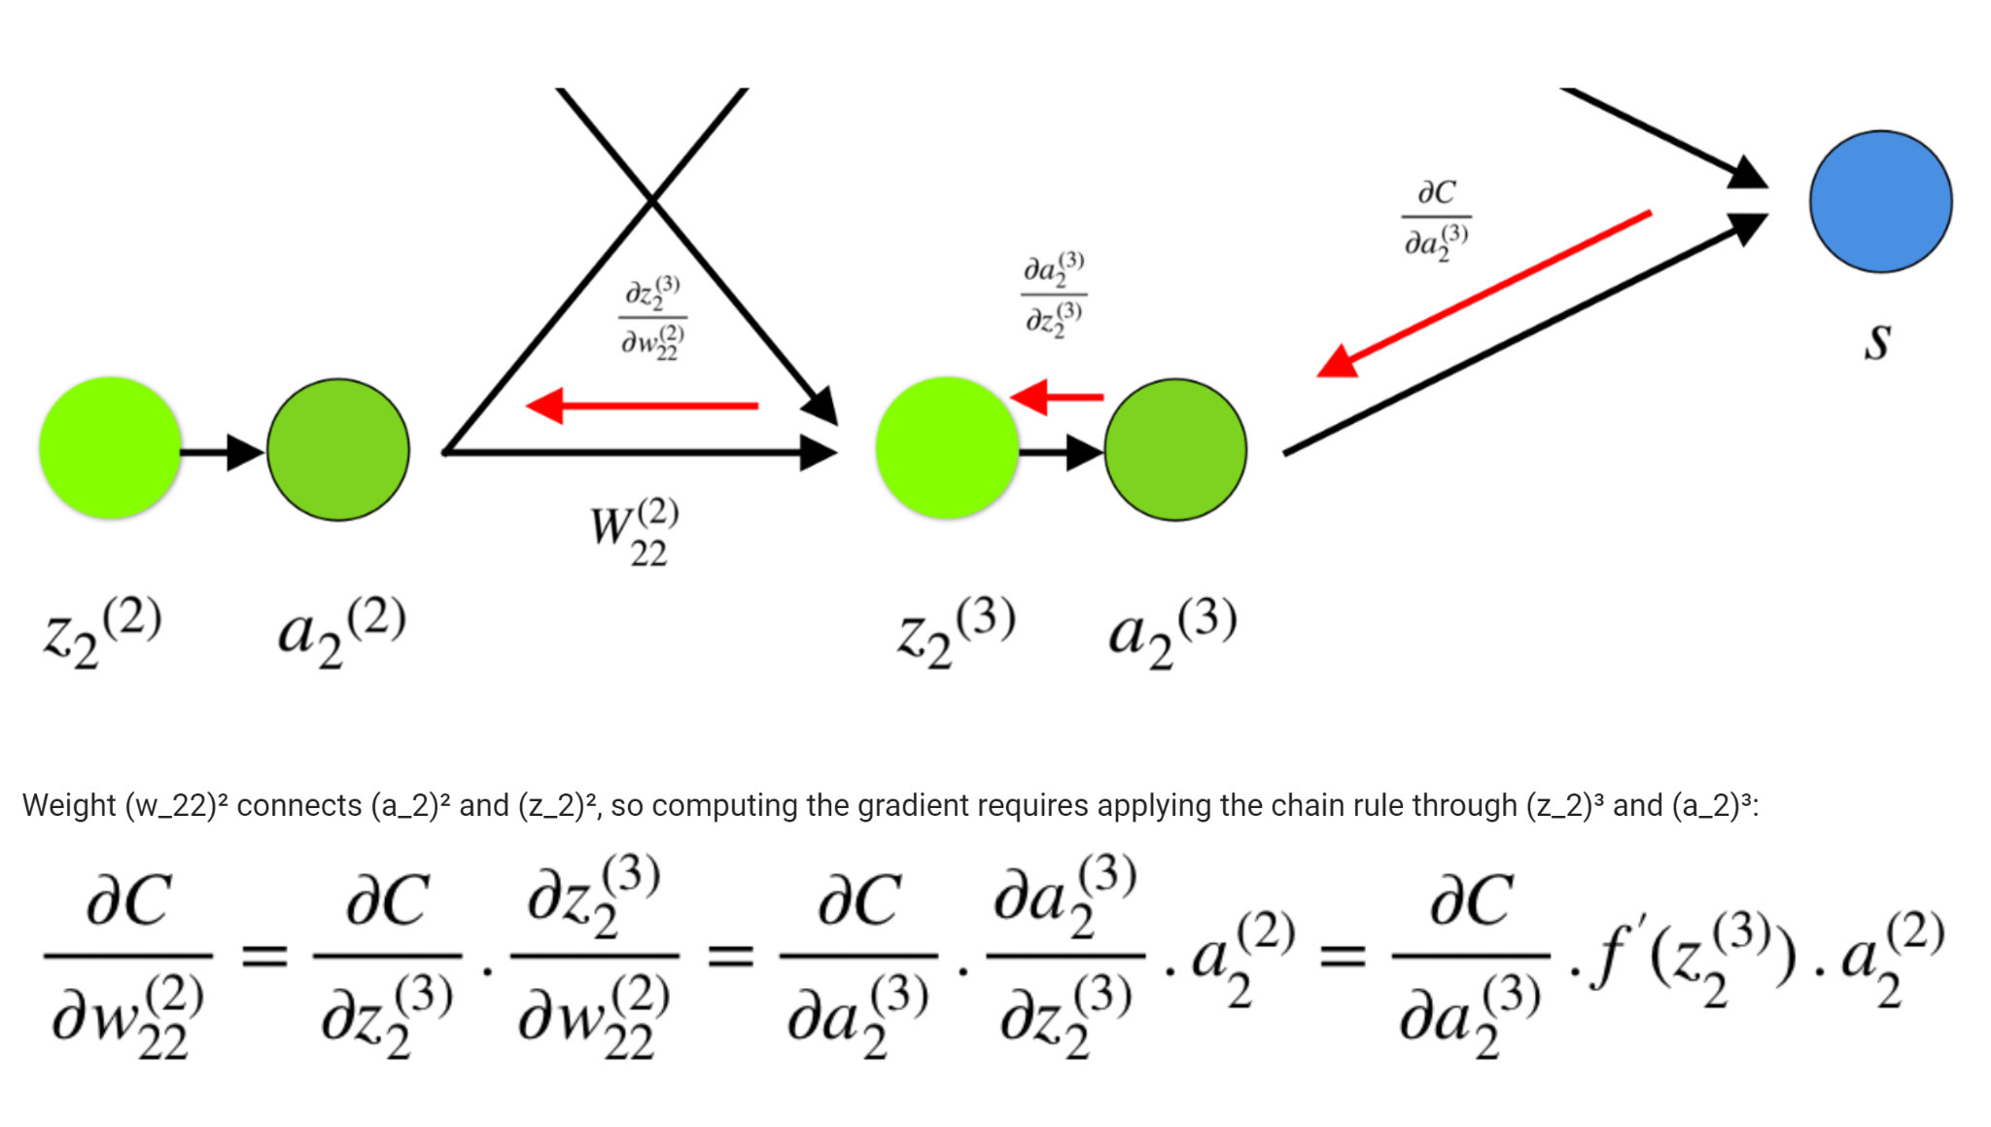

figure.11 Chain Rule

**Neural Network -** Itis a powerful and efficient way of getting a solution using pattern recognition. It is a widely used method to recognize patterns where in my research I have used it to determine emotion by remembering the pattern of the lips region.

* Neural Network is an efficient way of solving complex problems following the lemma “divide and conquer”.
* A complex system may be divided into simpler and smaller systems, in order to be able to understand it. Networks are one approach for achieving this.
* There are a large number of different types of networks, but they all are characterized by the following components: a set of nodes, and connections between nodes.
* Nodes can be seen as computational units. They receive inputs, and process them to obtain an output.
* This processing might be very simple (such as summing the inputs), or quite complex.
* The connections determine the information flow between nodes.
* They can be unidirectional, when the information flows only in one direction, and bidirectional, when the information flows in either direction.

**Artificial Neural Network (ANN) -** Biological human brain neural structure is more similar to this network. They are powerful tools for modeling, especially when the underlying data relationship is unknown. ANN can identify and learn similar patterns between input data sets and corresponding target values. After training ANN can be used to predict the outcome of new independent input data. As we mentioned ANN follows the learning process of the human brain and can process problems involving nonlinear and complex data even if the data are imprecise and noisy. It consists of simple computational units called neurons, which are highly interconnected. A very important feature of these networks is their adaptive nature where, “learning by example” replaces “programming” in solving problems. This feature makes such computational models very appealing in application domains.

**Convolutional Neural Networks -** Convolutional Neural Networks .Sounds like a weird combination of biology and math with a little CS sprinkled in, but these networks have been some of the most influential innovations in the field of computer vision. 2012 was the first year that neural nets grew to prominence as Alex KRIZHEVSKY used them to win that year‘s Image-Net competition (basically, the annual Olympics of computer vision),dropping the classification error record from 26% to 15%, an astounding improvement at the time. Ever since then, a host of companies have been using deep learning at the core of their services. Facebook uses neural nets for their automatic tagging algorithms, Google for their photo search, Amazon for their product recommendations, PINTEREST for their home feed personalization, and INSTAGRAM for their search infrastructure. When it comes to Machine Learning, Artificial Neural Networks perform really well. Artificial Neural Networks are used in various classification tasks like image, audio, words. Different types of Neural Networks are used for different purposes, for example for predicting the sequence of words we use Recurrent Neural Networks more precisely an LSTM, similarly for image classification we use Convolution Neural Network. Convolutional Neural Networks or covnets are neural networks that share their parameters. Imagine you have an image. It can be represented as a cuboid having its length, width (dimension of the image) and height (as images generally have red, green, and blue channels).

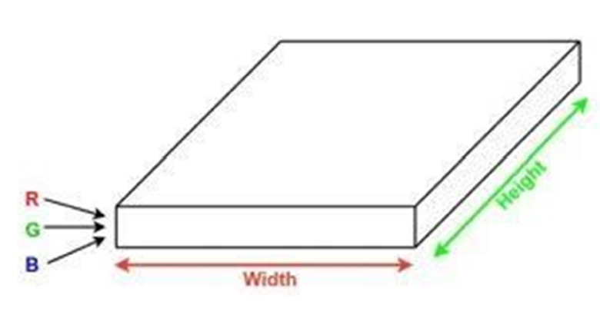

Figure :12 Dimension of image

Now imagine taking a small patch of this image and running a small neural network on it, with say, k outputs and representing them vertically. Now slide that neural network across the whole image, as a result, we will get another image with different width, height, and depth. Instead of just R, G and B channels now we have more channels but lesser width and height. This operation is called Convolution. If patch size is the same as that of the image it will be a regular neural network. Because of this small patch, we have fewer weights.

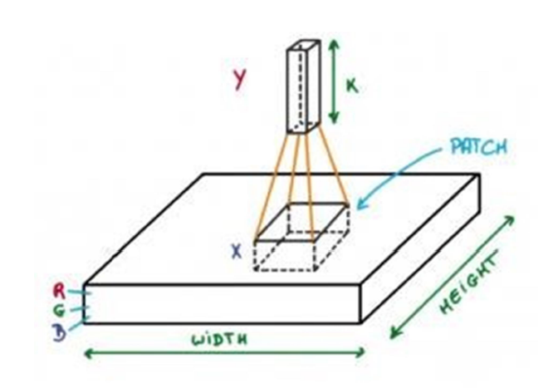

Figure: 13 convolution process

Now let‘s talk about a bit of mathematics which is involved in the whole convolution process.

* Convolution layers consist of a set of learnable filters (patch in the above image). Every filter has small width and height and the same depth as that of input volume (3 if the input layer is image input).
* For example, if we have to run convolution on an image with dimension 28x28x3. Possible size of filters can be 3, 5, 7, etc but small as compared to image dimension.
* During forward pass, we slide each filter across the whole input volume step by step where each step is called stride (which can have value 2 or 3 or even 4 for high dimensional images) and compute the dot product between the weights of filters and patch from input volume.
* As we slide our filters we‘ll get a 2-D output for each filter and we‘ll stack them together and as a result, we‘ll get output volume having a depth equal to the number of filters. The network will learn all the filters.

**Tensors:** In simple words, it's just an n-dimensional array in PyTorch. Tensors support some additional enhancements which make them unique: Apart from CPU, they can be loaded or the GPU for faster computations. On setting .requires_grad = True they start forming a backward graph that tracks every operation applied on them to calculate the gradients using something called a dynamic computation graph

A simple DCG for multiplication of two tensors would look like this:

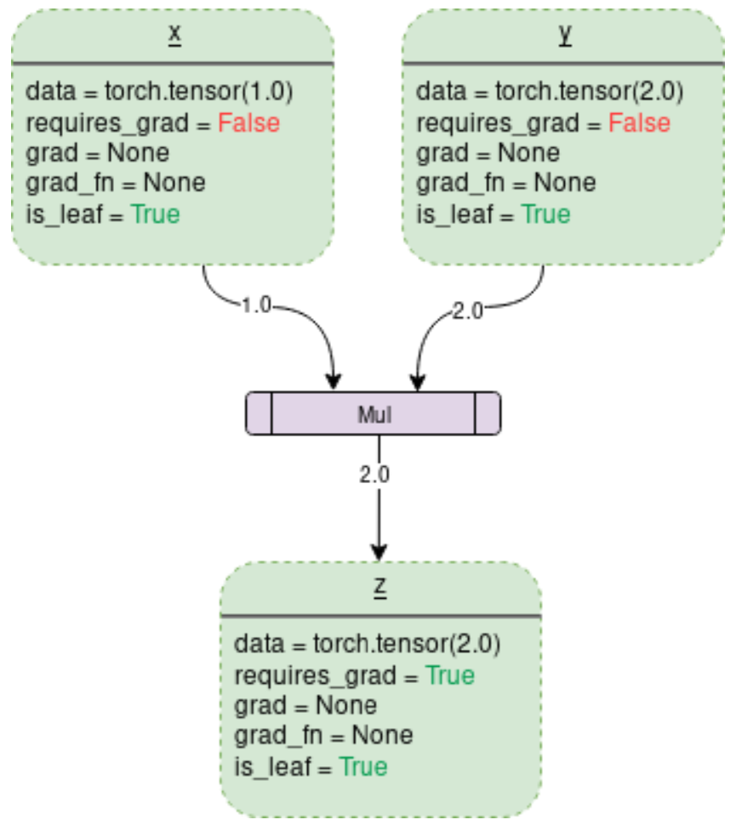

figure. 14 DCG Multiplication for two numbers

**Loss Function -** Loss functions measure how far an estimated value is from its true value.

**Activation Function -** activation function of a node defines the output of that node given an input or set of inputs.

f [ Sum{(weight * input)} + bias ]

**Bias -** Bias is just like an intercept added in a linear equation. It is an additional parameter in the Neural Network which is used to adjust the output along with the weighted sum of the inputs to the neuron. Moreover, the bias value allows you to shift the activation function to either right or left.

**Forward Pass -** The "forward pass" refers to the calculation process, values of the output layers from the inputs data. It's traversing through all neurons from the first to the last layer.

**Backward Pass -** then "backward pass" refers to the process of counting changes in weights (de facto learning), using gradient descent algorithm (or similar). Computation is made from the last layer, backward to the first layer.

**Iteration -** Backward and forward passes make together one "iteration".

**Batch / mini-batch -** During one iteration, you usually pass a subset of the data set, which is called "mini-batch" or "batch" (however, "batch" can also mean an entire set, hence the prefix "mini")

**Epoch -** Epoch means passing the entire data set in batches. One epoch contains (number_of_items / batch_size) iterations. Forward pass and backward pass together form an epoch.

**Vanishing Gradient Problem -**

* **Problem -** As more layers using certain activation functions are added to neural networks, the gradients of the loss function approaches zero, making the network hard to train.
* **Why -** Certain activation functions, like the sigmoid function, squishes a large input space into a small input space between 0 and 1. Therefore, a large change in the input of the sigmoid function will cause a small change in the output. Hence, the derivative becomes small. However, when n hidden layers use an activation like the sigmoid function, n small derivatives are multiplied together. Thus, the gradient decreases exponentially as we propagate down to the initial layers.
* **How to know if the model has these problems -** 
  + The model will improve very slowly during the training phase and it is also possible that training stops very early, meaning that any further training does not improve the model.
  + The weights closer to the output layer of the model would witness more of a change whereas the layers that occur closer to the input layer would not change much (if at all).
  + Model weights shrink exponentially and become very small when training the model.
  + The model weights become 0 in the training phase.

**Exploding Gradient Problem -**

* **Problem -** In a network of n hidden layers, n derivatives will be multiplied together. If the derivatives are large then the gradient will increase exponentially as we propagate down the model until they eventually explode, and this is what we call the problem of exploding gradient.
* **How to know if the model has these problems -** 
  + The model is not learning much on the training data therefore resulting in a poor loss.
  + The model will have large changes in loss on each update due to the models instability.
  + The models loss will be NaN during training.
  + Model weights grow exponentially and become very large when training the model.
  + The model weights become NaN in the training phase.
  + The derivatives are constantly
* **Solution -**
  + ReLU - which doesn’t cause a small derivative.
  + Reducing the amount of Layers
  + **Gradient Clipping -** If the gradient gets too large, we rescale it to keep it small. More precisely, if ‖g‖ ≥ c  
    **c . g/‖g‖**  
    where c is a hyperparameter, g is the gradient, and ‖g‖ is the norm of g. Since g/‖g‖ is a unit vector, after rescaling the new g will have norm c. Note that if ‖g‖ < c, then we don’t need to do anything.
  + **Residual networks -** as they provide residual connections straight to earlier layers. The residual connection directly adds the value at the beginning of the block, x, to the end of the block (F(x)+x). This residual connection doesn’t go through activation functions that “squashes” the derivatives, resulting in a higher overall derivative of the block.

**Degradation Problem -**

If a “shallow” model is able to achieve an accuracy, then their deeper counterparts should at least have the same accuracy. But, when the model gets deeper, it becomes more and more difficult for the layers to propagate the information from shallow layers and the information is lost. This is called the Degradation Problem.

**RESNET18**

In order to solve the problem of the vanishing/exploding gradient and Degradation problem, this architecture introduced the concept called Residual Network. In this network we use a technique called skip connections . The skip connection skips training from a few layers and connects directly to the output.

**Residual Learning -**

* Let g(x) be the function learned by the layers. Let’s consider h(x) = g(x)+x, layers with skip connections. Here +x term denotes the skip connection.
* In h(x)=g(x)+x, the +x term will bring the original value, layer g(x) has to learn just the changes in the value, or the residue or delta x.
* Whatever being learned in g(x) is just the residue, either positive or negative to modify x to required value. Hence the name “Residual Learning”.
* For h(x) to be identity function, the residue g(x) just has to become zero function, which is very easy to learn, i.e. set all weights to zero. Then h(x) = 0+x = x, which is the required identity function. This will help overcome the degradation problem.

**Skip connection -**

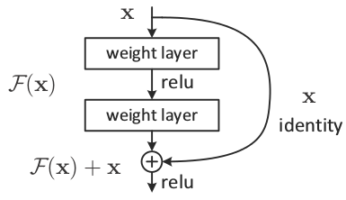

figure.15 Skip Connection

**Why is the relu applied after adding the skip connection?**

* If we had performed relu before addition, then the residues will all be positive or zero. Only positive increments to the identity are learnt, which significantly reduces the learning capacity.
* For example in the sin function, sin(3π/2) = -1, which would need negative residue.
* Similarly, using sigmoid will also be disadvantageous, because it produces residues only within 0 to 1.
* Ideally, we would like an unconstrained response from the weight layer (spanning any numerical range), to be added to the skip layer, then apply activation to provide non-linearity. This helps the model learn any function.

**Why are there two weight layers in one residual block?**

* if we had used a single weight layer, adding skip connection before relu, gives F(x) = Wx+x, which is a simple linear function.
* This is equivalent to just a single weight layer and there is no point in adding skip connection.
* So we need at least one non-linearity before adding skip connection, which is achieved by using two layers.

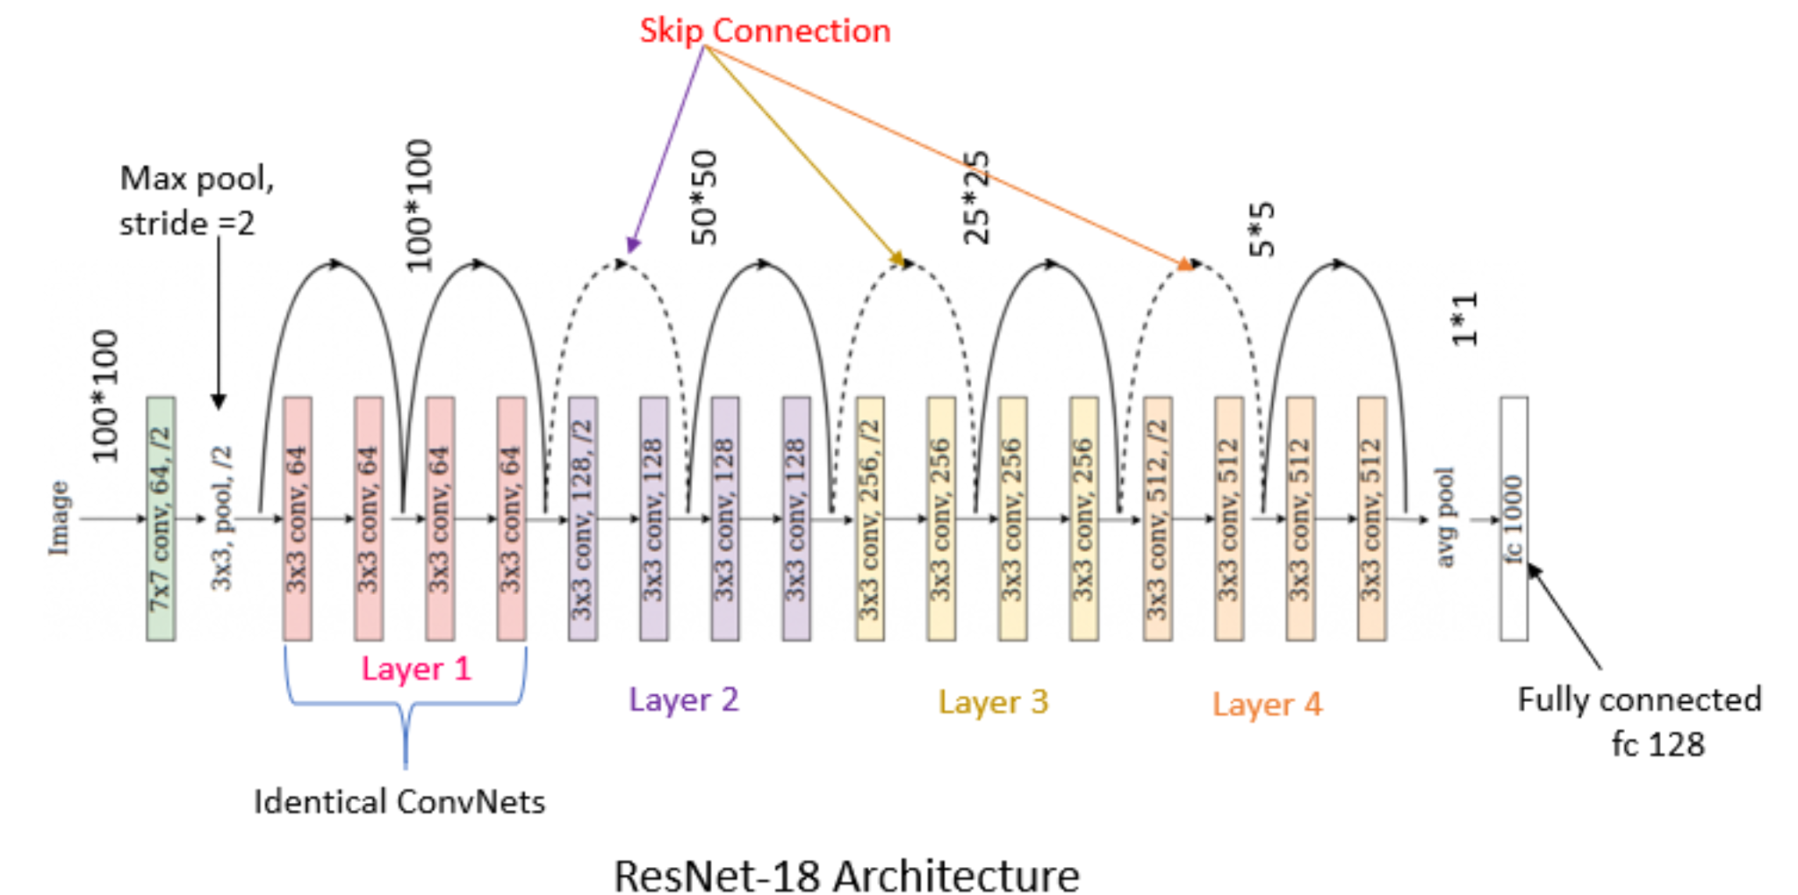

figure.16 ResNet-18 Architecture

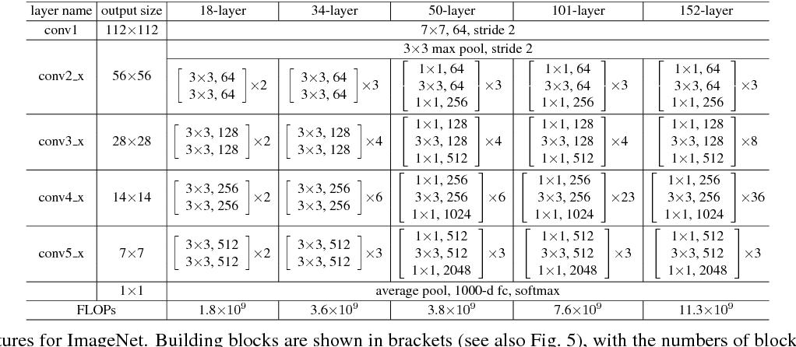

figure.17 Building blocks

* X is input, Y is output , Y=F(X). The logic behind RESNET is to make Input=Output
* If we make F(X)=0, then it is easy for us to make input = output  
  Y=F(X)+X  
  Y=X+0  
  Y=X
* In normal networks we learn from Y but in Residual network we learn from F(X) and our target is to make F(X)=0 then only we can make input=output
* RESNET 1st introduced the concept of skip connection.
* Here, we add the original input to the output of the convolutional block
* It has 18 layers

**Identity Block (**Input size = Output size) **-** Identity Block is used when there is no change in input and output dimensions. Convolutional block is almost the same as the identity block but there is a convolutional layer in the short-cut path to just change the dimension such that the dimension of input and output matches.

Here is identity block:

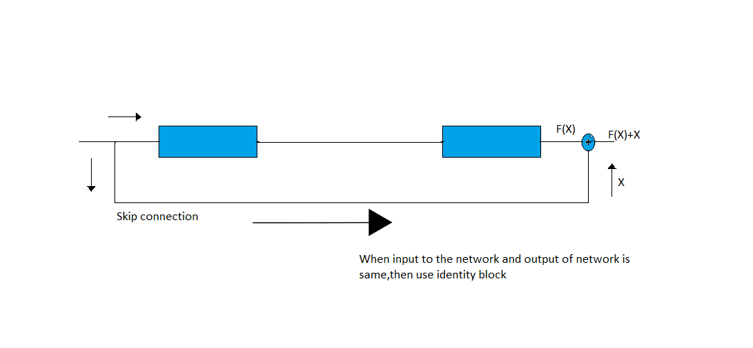

figure.19 Identity Block

**Convolutional Block (**Input size != Output size) **-** It consists of the Convolution Layer and the Pooling Layer. This layer forms the essential component of Feature-Extraction. The Fully Connected Block — Consists of a fully connected simple neural network architecture.

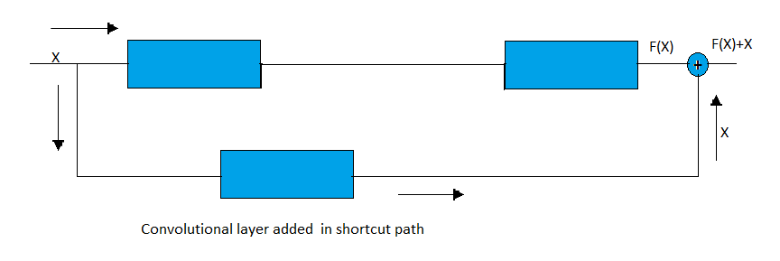

figure.20 Convolutional Block

**Convolutional Operation -** We do element wise multiplication using a kernel on the input image & it is used for feature extraction.

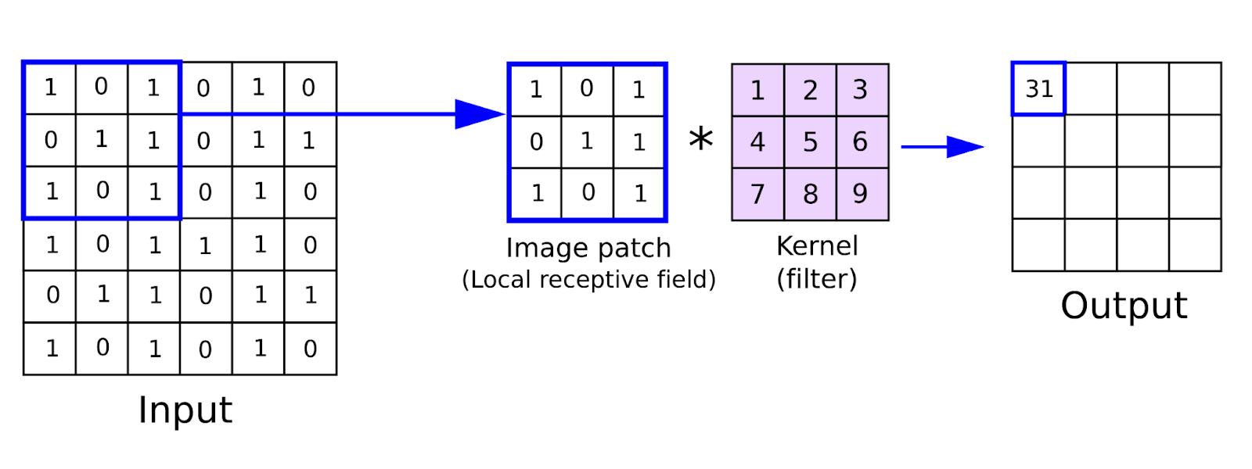

figure.21 Convolutional Operation

**Pooling Operation -**  Pooling reduces the size of the feature map in order to help us with using the fewer parameters in the network i.e dimensionality reduction. Pooling makes the activation representation (obtained from convolving the filter over the input combination of input and weight values) smaller and more manageable.

3 types –

* Min - Pixel with Minimum value is selected
* Max – Pixel with Maximum value is selected
* Average – Average of the pixel value is taken

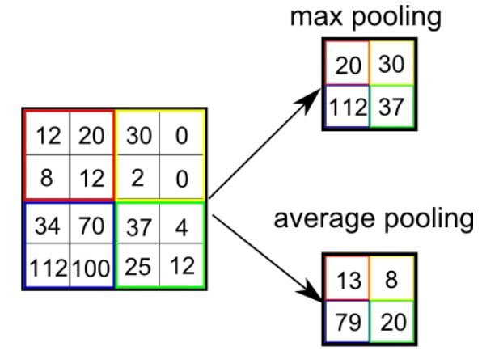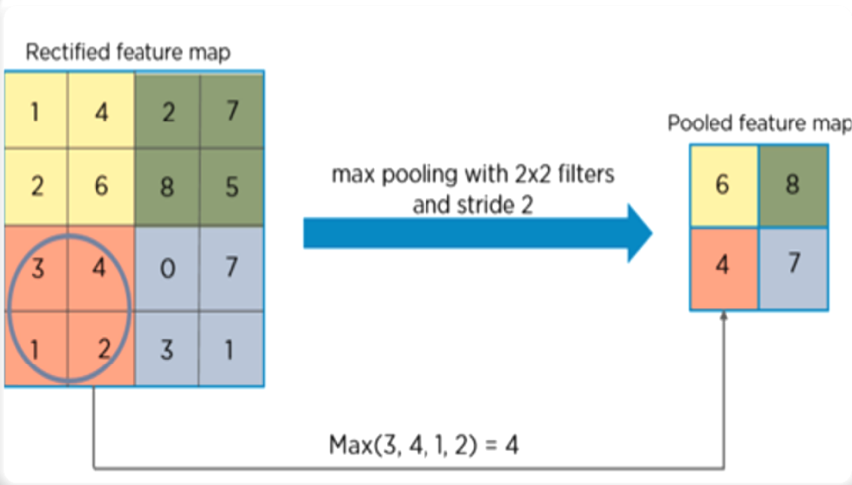

figure.22 Pooling Operation

Creating and training a neural network involves the following essential steps:

* Define the architecture
* Forward propagate on the architecture using input data
* Calculate the loss
* Backpropagate to calculate the gradient for each weight
* Update the weights using a learning rate

**CUDA -Compute Unified Device Architecture -** CUDA is a parallel computing platform developed by NVIDIA and introduced in 2006. It enables software programs to perform calculations using both the CPU and GPU.

**Batch Normalization -** Batch normalization is a technique for training very deep neural networks that standardizes the inputs to a layer for each mini-batch. This has the effect of stabilizing the learning process and dramatically reducing the number of training epochs required to train deep networks.

**Batch Normalization 2d -** Applies Batch Normalization over a 4D input (a mini-batch of 2D inputs with additional channel dimension) as described in the paper Batch Normalization: Accelerating Deep Network Training by Reducing Internal Covariate Shift .

**Optimizers -** Optimizers are algorithms or methods used to change the attributes of the neural network such as weights and learning rate to reduce the losses.

**Adam Optimizer -** Adam is a replacement optimization algorithm for stochastic gradient descent for training deep learning models. Adam combines the best properties of the AdaGrad and RMSProp algorithms to provide an optimization algorithm that can handle sparse gradients on noisy problems. Stochastic gradient descent maintains a single learning rate (termed alpha) for all weight updates and the learning rate does not change during training. A learning rate is maintained for each network weight (parameter) and separately adapted as learning unfolds. Adam is a popular algorithm in the field of deep learning because it achieves good results fast

Adam was combining the advantages of two other extensions of stochastic gradient descent. Specifically:

* Adaptive Gradient Algorithm (AdaGrad) that maintains a per-parameter learning rate that improves performance on problems with sparse gradients (e.g. natural language and computer vision problems).
* Root Mean Square Propagation (RMSProp) that also maintains per-parameter learning rates that are adapted based on the average of recent magnitudes of the gradients for the weight (e.g. how quickly it is changing). This means the algorithm does well on online and non-stationary problems (e.g. noisy).

Instead of adapting the parameter learning rates based on the average first moment (the mean) as in RMSProp, Adam also makes use of the average of the second moments of the gradients (the uncentered variance).

Specifically, the algorithm calculates an exponential moving average of the gradient and the squared gradient, and the parameters beta1 and beta2 control the decay rates of these moving averages.

The initial value of the moving averages and beta1 and beta2 values close to 1.0 (recommended) result in a bias of moment estimates towards zero. This bias is overcome by first calculating the biased estimates before then calculating bias-corrected estimates.

**Loss Function -** Loss functions define what a good prediction is and isn't a way to measure how well the model is performing.

**NLL Loss Function -** The negative log likelihood loss. It is useful to train a classification problem with C classes. If provided, the optional argument weight should be a 1D Tensor assigning weight to each of the classes. This is particularly useful when you have an unbalanced training set.

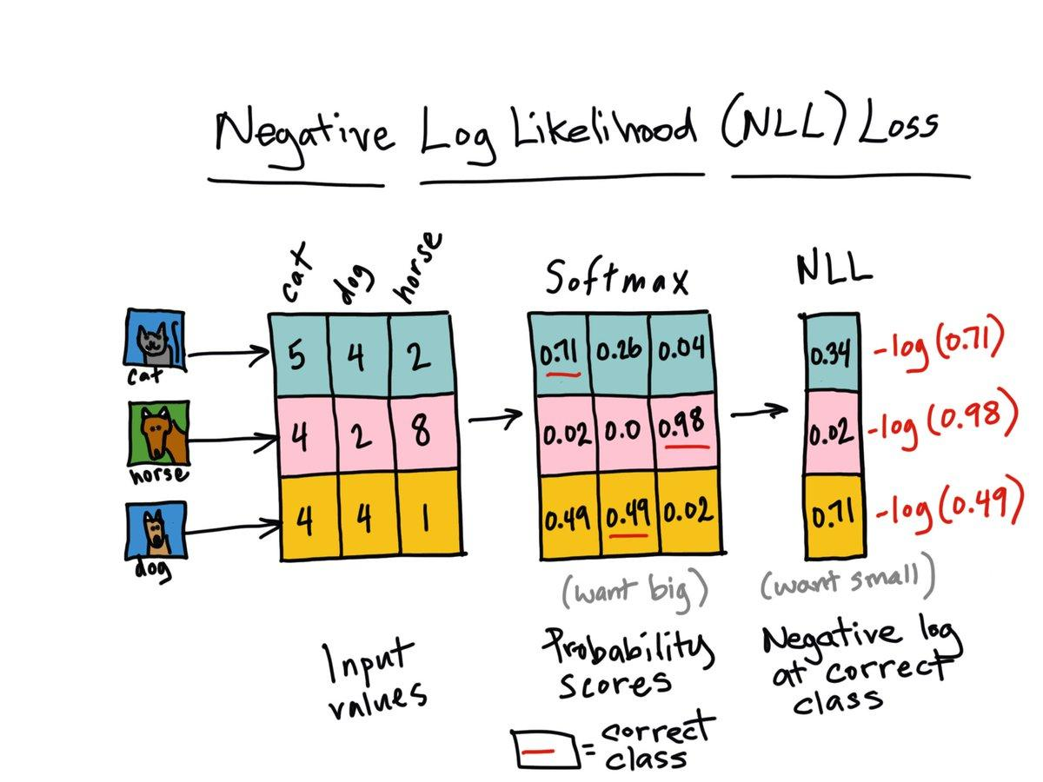

figure.23 NLL Loss Function

|  |  |  |  |  |
| --- | --- | --- | --- | --- |
| **Sl. No.** | **Journal Type and year** | **Authors** | **Title** | **Summary** |
| 1 | IEEE, 2017 | Mateusz Buda, Atsuto Maki, Maciej A. Mazurowski | A systematic study of the class imbalance problem  in convolutional neural networks | As opposed to some classical machine learning models, oversampling does not cause overfitting of CNNs |
| 2 | IEEE, 2015 | Kaiming He, Xiangyu Zhang, Shaoqing Ren, Jian Sun | Deep Residual Learning for Image Recognition | residual  networks are easier to optimize, and can gain accuracy from  considerably increased depth. |
| 3 | IEEE, 2019 | Connor Taghi M. Khoshgoftaar | A survey on Image Data Augmentation  for Deep Learning | Comparative study of various augmentation techniques |
| 4 | IEEE, 2020 | Wanwan Zheng Mingzhe Jin | The Effects of Class Imbalance and Training Data Size on Classifier  Learning | naïve Bayes, logistic regression model is less  susceptible to class imbalance while they have relatively poor predictive performance |
| 5 | IEEE, 2017 | Marcus D. Bloice, Christof Stocker, Andreas Holzinger | Augmentor: An Image Augmentation Library for Machine Learning | Augmentor makes it easier to perform artificial data generation, by providing a stochastic, pipeline-based API that allows for fine-grained control over the creation of augmented data and provides many functions for augmentation techniques. |

Table 1: Literature Survey

**TOOLS USED**

**3. Tools used**

**3.1 Software Requirement Specification -**

Requirement analysis is mainly categorized into two types:

**3.1.1. Functional requirements -** The functional requirements for a system describe what the system should do. Those requirements depend on the type of software being developed, the expected users of the software. These are statements of services the system should provide, how the system should react to particular inputs and how the system should behave in particular situations.

**3.1.2. Non-Functional requirements -** Nonfunctional requirements are requirements that are not directly concerned with the specified function delivered by the system. They may relate to emergent system properties such as reliability, response time and store occupancy. Some of the nonfunctional requirements related with this system are hereby below:

1. **Reliability -** Reliability based on this system defines the evaluation result of the system, correct identification of the facial expressions and maximum evaluation rate of the facial expression recognition of any input images.
2. **Ease of Use -** The system is simple, user friendly, graphics user interface implemented so anyone can use this system without any difficulties.

**3.2 Feasibility Study -**

Before starting the project, a feasibility study is carried out to measure the viability of the system. Feasibility study is necessary to determine if creating a new or improved system is friendly with the cost, benefits, operation, technology and time. Following feasibility study is given as below -

**3.2.1 Technical Feasibility -** Technical feasibility is one of the first studies that must be conducted after the project has been identified. Technical feasibility study includes the hardware and software devices. The required technologies (Python language and Anaconda IDE) existed.

**3.2.2 Operational Feasibility -** Operational Feasibility is a measure of how well a proposed system solves the problem and takes advantage of the opportunities identified during scope definition. The following points were considered for the project’s technical feasibility:

**3.2.2.1** The augmentation is applied on the minority class to balance the classes  
**3.2.2.2** The system will classify the images into classes.

**3.2.3 Economic Feasibility -** The purpose of economic feasibility is to determine the positive economic benefits that include quantification and identification. The system is economically feasible due to availability of all requirements such as collection of data from

**3.2.3.1.** Intel Scene Dataset

**3.2.4 Schedule Feasibility -** Schedule feasibility is a measure of how reasonable the project timetable is. The system is found to be feasible because the system is designed in such a way that it will finish prescribed time.

**3.3. Software and Hardware Requirement -**

**3.3.1 Software Requirement -** Following are the software requirement necessary of the project -

1. **Python3.9 - programming language**
2. **Anaconda IDE / Google Colab (selective)**
3. **Windows OS**
4. **Libraries -**
   1. **Numpy -** NumPy, which stands for Numerical Python, is a library consisting of multidimensional array objects and a collection of routines for processing those arrays. Using NumPy, mathematical and logical operations on arrays can be performed.
   2. **PIL (Pillow Image Library) -** Python Imaging Library is a free and open-source additional library for the Python programming language that adds support for opening, manipulating, and saving many different image file formats. It is available for Windows, Mac OS X and Linux. The latest version of PIL is 1.1.
   3. **OpenCV -** OpenCV is a great tool for image processing and performing computer vision tasks. It is an open-source library that can be used to perform tasks like face detection, objection tracking, landmark detection, and much more. It supports multiple languages including python, java C++. OpenCV is written in C and C++ whereas PIL is written using Python and C, hence just from this information, OpenCV seems faster. 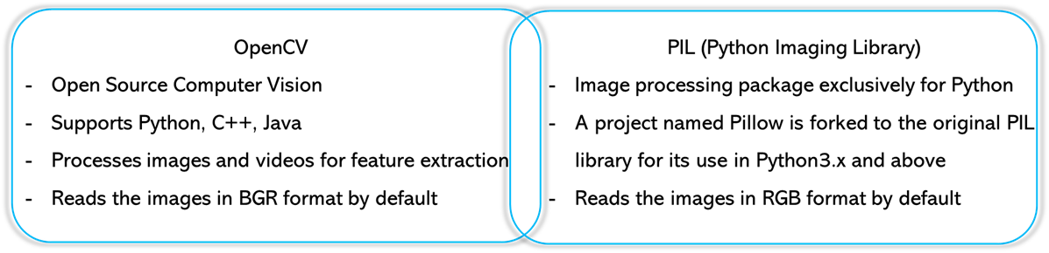  
       figure.24 Difference b/w OpenCV and PIL
   4. **Sys -** The sys module in Python provides various functions and variables that are used to manipulate different parts of the Python runtime environment. It allows operating on the interpreter as it provides access to the variables and functions that interact strongly with the interpreter.
   5. **Torch (Version - '1.10.0') -** Torch is an open-source machine learning library, a scientific computing framework, and a script language based on the Lua programming language. It provides a wide range of algorithms for deep learning, and uses the scripting language LuaJIT, and an underlying C implementation.
   6. **Os -** The OS module in Python provides functions for interacting with the operating system. OS comes under Python's standard utility modules. This module provides a portable way of using operating system-dependent functionality.
   7. **Time –** It is a package which helps to measure time.

**3.3.2 Hardware Requirement -** Following are the hardware requirement that is most important for the project:

1. Fluently working Laptops
2. RAM minimum 8Gb
3. GPU

**IMPLEMENTATION, TESTING AND FINDINGS**

**4 Project Methodology**

**4.1 System Design**The model performance is being improved with the removing the class imbalance problem using various Augmentation approaches by building a custom Augmented Dataset generator & a Custom Augmentation library. The parameters on which the techniques will be compared are on accuracy to solve the Class imbalance problem to maximize accuracy and reduce error & find the best possible method to solve it. System design shows the overall design of the system. In this section we discuss in detail the design aspects of the system

**4.2 System Diagram**

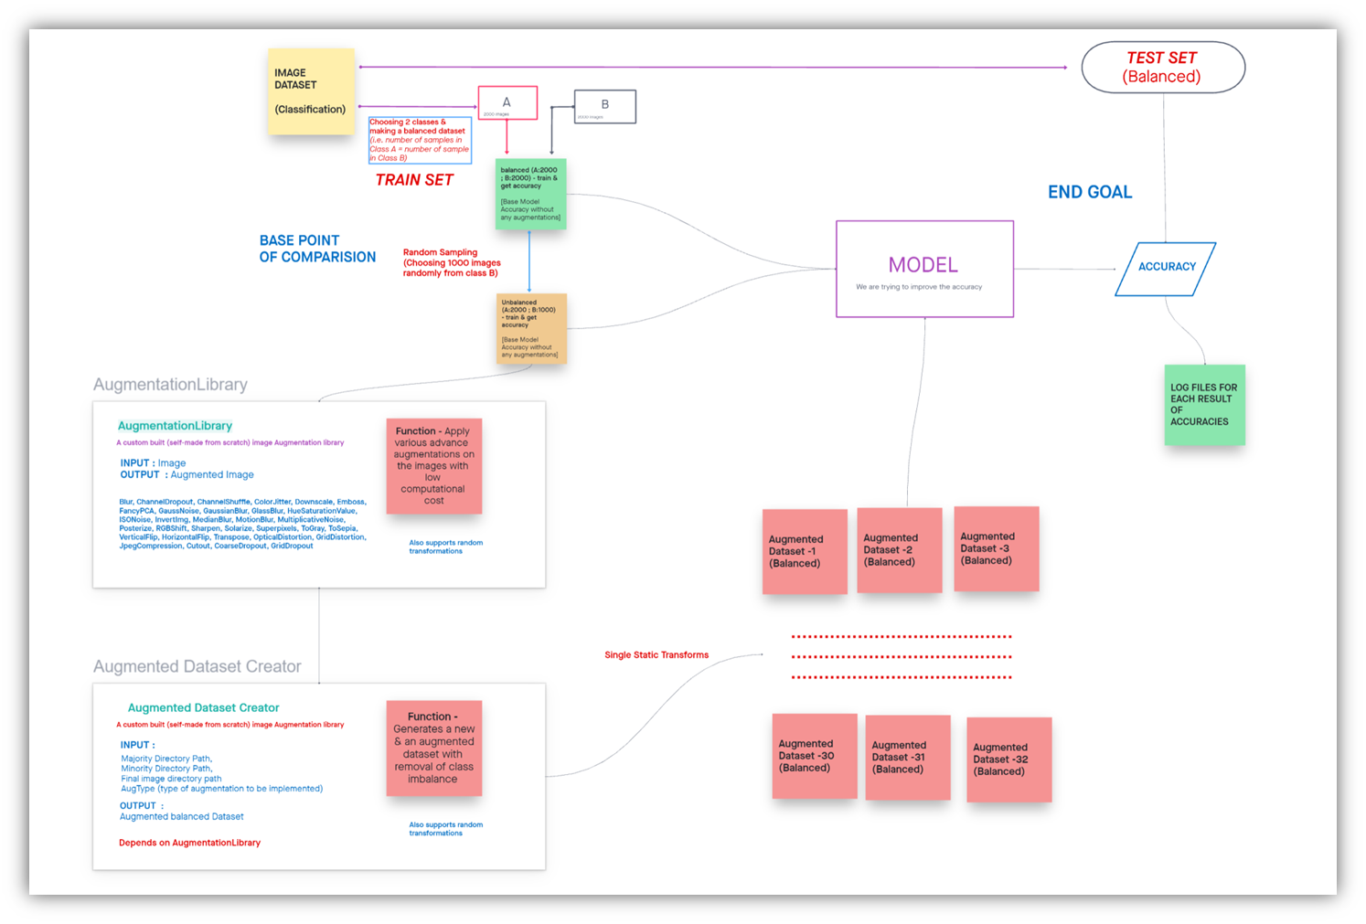

figure.25 System Diagram

Initially we are taking a classification image data set. It has a train and test set. The train set is used to train the model. Once the model is trained it is tested upon the test set and we are storing the accuracies in a log file for our records.

We are choosing two classes out of it for balancing the dataset i.e. making the number of samples in class A equal to number of sample in class B

We are passing it through the model and testing it with the test set and we are getting the accuracy.

We are creating an imbalance by choosing some random samples from class B and making an unbalanced data set which has the same number of images in class A and smaller images sampled in class B. We are passing it through the model and finding and storing in the accuracy

We are applying an augmentation technique to remove the class imbalance problem. For example if there is a cat image we are making a new augmented image in which it has undergone some transformations like we can rotate or flip or increase the brightness or increase the contrast, etc. So, different types of augmentation techniques are applied to make a new image so that the model could learn even if there are fewer samples in a class compared to others or if the sample dataset has less number of samples. We are making new samples using the existing samples. This helps the model to learn better even if there is less data available.

We are applying various augmentation techniques on the unbalanced data set and we generate different augmented balanced data sets. We are passing it through the model, training the model, finding the test accuracy & storing it in a log text file for our record.

Based on the accuracies of all types of augmented balanced datasets, we evaluate the augmentation techniques.

In the custom built augmentation library takes an input image, applies advanced augmentation techniques on these images and returns an augmented image. The library is better than others as it has low computational cost unlike in tensorflow or pytorch augmentation libraries that convert images to a tensor, applying the transformation on the tensor and again changing back the array into image. So, To reduce this, we directly applied the transformation on the image array and returned an augmented image. It supports many types of augmentations as follows:

* Blur - Blur the input image using a random-sized kernel.
* CLAHE - Apply Contrast Limited Adaptive Histogram Equalization to the input image.
* ChannelDropout - Drops out a channel based on a range
* ChannelShuffle - Randomly rearrange channels of the input RGB image.
* ColorJitter - Randomly changes the brightness, contrast, and saturation of an image.
* Downscale - Decreases image quality by downscaling and upscaling back.
* Emboss - Emboss the input image and overlays the result with the original image.
* FancyPCA - Augment RGB image using FancyPCA from Krizhevsky's paper "ImageNet Classification with Deep Convolutional Neural Networks"
* GaussNoise - Apply gaussian noise to the input image.
* GaussianBlur - Blur the input image using a Gaussian filter with a random kernel size.
* GlassBlur - Apply glass noise to the input image.
* HueSaturationValue - Randomly change hue, saturation and value of the input image.
* ISONoise - Apply camera sensor noise.
* InvertImg - Invert the input image by subtracting pixel values from 255.
* MedianBlur - Blur the input image using a median filter with a random aperture linear size.
* MotionBlur - Apply motion blur to the input image using a random-sized kernel.
* MultiplicativeNoise - Multiply image to random number or array of numbers.
* Posterize - Reduce the number of bits for each color channel.
* RGBShift - Randomly shift values for each channel of the input RGB image.
* Sharpen - Sharpen the input image and overlays the result with the original image.
* Solarize - Invert all pixel values above a threshold.
* Superpixels - Transform images partially/completely to their superpixel representation. This implementation uses skimage's version of the SLIC algorithm.
* ToGray - Convert the input RGB image to grayscale. If the mean pixel value for the resulting image is greater than 127, invert the resulting grayscale image.
* ToSepia - Applies sepia filter to the input RGB image
* VerticalFlip - Flip the input vertically around the x-axis.
* HorizontalFlip - Flip the input horizontally around the y-axis.
* Transpose - Transpose the input by swapping rows and columns.
* OpticalDistortion - Distortion can be thought of as the difference in magnification across a field of view. This is usually calculated as a percentage of image size. By taking the measured distance in the image and comparing it to the predicted distance, we can calculate the optical distortion
* GridDistortion - Grid-distortion is an image warping technique which is driven by the mapping between equivalent families of curves, arranged in a grid structure. Until recently only curve sets arranged in a regular rectangular grid were considered.
* JpegCompression - Decrease Jpeg compression of an image.
* Cutout - CoarseDropout of the square regions in the image
* CoarseDropout - CoarseDropout of the rectangular regions in the image
* GridDropout - GridDropout, drops out rectangular regions of an image and the corresponding mask in a grid fashion.

The augmented data set creator uses an augmentation library that generates a new augmented balanced dataset. The unbalanced data set that we gave as an input is balanced by applying various augmentation techniques with the existing samples. The model is trained with these datasets and the test accuracy is stored for our evaluation.

**4.3. Extensions made on the Existing Model**

* Compared many Augmentation libraries, and chosen the best one based on various parameters
* Built a new Augmentation library from scratch - Static Aug Library & Random Aug Library
* Unit-Tested the Augmentation library using Unit-Test Library to make it efficient. Testing Static Aug Library & Testing Random Aug Library
* Created a detailed summary of each type of augmentations that the library supports
* Developed a Dataset Balance & Unbalance Creator
* Built a Augmentation Dataset Creator based on the Augmentation library
* Implemented the RESNET18 model [pre-trained = False]
* Added layers to get the accuracy metrics – train & test accuracies
* Ran for 100 epochs for each test case [Augmented Dataset ] & choosing the best trained model using the test accuracies
* Added the logging code to store the log file for every experiment
* Ran the test cases for 1:2, 1:4, 1:8, 1:16, 1:20 imbalance
* Ran the tests for both static & Random Augmentations
* Analyzed & compared the results to compare the augmentations that improve the model accuracy

**Model Architecture & summary**

**5. Model Architecture & summary**

**5.1. Model Architecture**

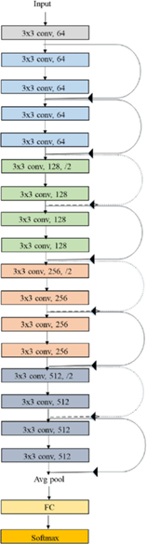

figure.18 ResNet 18-Layers

* X is input, Y is output , Y=F(X). The logic behind RESNET is to make Input=Output
* If we make F(X)=0, then it is easy for us to make input = output  
  Y=F(X)+X  
  Y=X+0  
  Y=X
* In normal networks we learn from Y but in Residual network we learn from F(X) and our target is to make F(X)=0 then only we can make input=output
* RESNET 1st introduced the concept of skip connection.
* Here, we add the original input to the output of the convolutional block
* It has 18 layers

**5.2. Model summary**

ResNet(

(conv1): Conv2d(3, 64, kernel_size=(7, 7), stride=(2, 2), padding=(3, 3), bias=False)

(bn1): BatchNorm2d(64, eps=1e-05, momentum=0.1, affine=True, track_running_stats=True)

(relu): ReLU(inplace=True)

(maxpool): MaxPool2d(kernel_size=3, stride=2, padding=1, dilation=1, ceil_mode=False)

(layer1): Sequential(

(0): BasicBlock(

(conv1): Conv2d(64, 64, kernel_size=(3, 3), stride=(1, 1), padding=(1, 1), bias=False)

(bn1): BatchNorm2d(64, eps=1e-05, momentum=0.1, affine=True, track_running_stats=True)

(relu): ReLU(inplace=True)

(conv2): Conv2d(64, 64, kernel_size=(3, 3), stride=(1, 1), padding=(1, 1), bias=False)

(bn2): BatchNorm2d(64, eps=1e-05, momentum=0.1, affine=True, track_running_stats=True)

)

(1): BasicBlock(

(conv1): Conv2d(64, 64, kernel_size=(3, 3), stride=(1, 1), padding=(1, 1), bias=False)

(bn1): BatchNorm2d(64, eps=1e-05, momentum=0.1, affine=True, track_running_stats=True)

(relu): ReLU(inplace=True)

(conv2): Conv2d(64, 64, kernel_size=(3, 3), stride=(1, 1), padding=(1, 1), bias=False)

(bn2): BatchNorm2d(64, eps=1e-05, momentum=0.1, affine=True, track_running_stats=True)

)

)

(layer2): Sequential(

(0): BasicBlock(

(conv1): Conv2d(64, 128, kernel_size=(3, 3), stride=(2, 2), padding=(1, 1), bias=False)

(bn1): BatchNorm2d(128, eps=1e-05, momentum=0.1, affine=True, track_running_stats=True)

(relu): ReLU(inplace=True)

(conv2): Conv2d(128, 128, kernel_size=(3, 3), stride=(1, 1), padding=(1, 1), bias=False)

(bn2): BatchNorm2d(128, eps=1e-05, momentum=0.1, affine=True, track_running_stats=True)

(downsample): Sequential(

(0): Conv2d(64, 128, kernel_size=(1, 1), stride=(2, 2), bias=False)

(1): BatchNorm2d(128, eps=1e-05, momentum=0.1, affine=True, track_running_stats=True)

)

)

(1): BasicBlock(

(conv1): Conv2d(128, 128, kernel_size=(3, 3), stride=(1, 1), padding=(1, 1), bias=False)

(bn1): BatchNorm2d(128, eps=1e-05, momentum=0.1, affine=True, track_running_stats=True)

(relu): ReLU(inplace=True)

(conv2): Conv2d(128, 128, kernel_size=(3, 3), stride=(1, 1), padding=(1, 1), bias=False)

(bn2): BatchNorm2d(128, eps=1e-05, momentum=0.1, affine=True, track_running_stats=True)

)

)

(layer3): Sequential(

(0): BasicBlock(

(conv1): Conv2d(128, 256, kernel_size=(3, 3), stride=(2, 2), padding=(1, 1), bias=False)

(bn1): BatchNorm2d(256, eps=1e-05, momentum=0.1, affine=True, track_running_stats=True)

(relu): ReLU(inplace=True)

(conv2): Conv2d(256, 256, kernel_size=(3, 3), stride=(1, 1), padding=(1, 1), bias=False)

(bn2): BatchNorm2d(256, eps=1e-05, momentum=0.1, affine=True, track_running_stats=True)

(downsample): Sequential(

(0): Conv2d(128, 256, kernel_size=(1, 1), stride=(2, 2), bias=False)

(1): BatchNorm2d(256, eps=1e-05, momentum=0.1, affine=True, track_running_stats=True)

)

)

(1): BasicBlock(

(conv1): Conv2d(256, 256, kernel_size=(3, 3), stride=(1, 1), padding=(1, 1), bias=False)

(bn1): BatchNorm2d(256, eps=1e-05, momentum=0.1, affine=True, track_running_stats=True)

(relu): ReLU(inplace=True)

(conv2): Conv2d(256, 256, kernel_size=(3, 3), stride=(1, 1), padding=(1, 1), bias=False)

(bn2): BatchNorm2d(256, eps=1e-05, momentum=0.1, affine=True, track_running_stats=True)

)

)

(layer4): Sequential(

(0): BasicBlock(

(conv1): Conv2d(256, 512, kernel_size=(3, 3), stride=(2, 2), padding=(1, 1), bias=False)

(bn1): BatchNorm2d(512, eps=1e-05, momentum=0.1, affine=True, track_running_stats=True)

(relu): ReLU(inplace=True)

(conv2): Conv2d(512, 512, kernel_size=(3, 3), stride=(1, 1), padding=(1, 1), bias=False)

(bn2): BatchNorm2d(512, eps=1e-05, momentum=0.1, affine=True, track_running_stats=True)

(downsample): Sequential(

(0): Conv2d(256, 512, kernel_size=(1, 1), stride=(2, 2), bias=False)

(1): BatchNorm2d(512, eps=1e-05, momentum=0.1, affine=True, track_running_stats=True)

)

)

(1): BasicBlock(

(conv1): Conv2d(512, 512, kernel_size=(3, 3), stride=(1, 1), padding=(1, 1), bias=False)

(bn1): BatchNorm2d(512, eps=1e-05, momentum=0.1, affine=True, track_running_stats=True)

(relu): ReLU(inplace=True)

(conv2): Conv2d(512, 512, kernel_size=(3, 3), stride=(1, 1), padding=(1, 1), bias=False)

(bn2): BatchNorm2d(512, eps=1e-05, momentum=0.1, affine=True, track_running_stats=True)

)

)

(avgpool): AdaptiveAvgPool2d(output_size=(1, 1))

(fc): Sequential(

(0): Linear(in_features=512, out_features=512, bias=True)

(1): ReLU()

(2): Dropout(p=0.2, inplace=False)

(3): Linear(in_features=512, out_features=2, bias=True)

(4): LogSoftmax(dim=1)

)

)

**EXPERIMENTATION AND RESULTS**

**6. EXPERIMENTATION AND RESULTS**

The aim of this paper is to solve class imbalance problems using Random Sampling and advanced data augmentation techniques. It included comparison of many augmentation libraries, and chose the best one based on various parameters, built a new Augmentation library, analyzed each type of augmentations that the library supports. We balanced the 2 classes of original datasets by developing a Dataset Balance & created an imbalance randomly by using an unbalance creator. An augmentation Dataset Creator was built that used the Augmentation library. The datasets generated are used to train the RESNET18 model with additional layers to get the accuracy metrics – train & test accuracies. The model is run for 100 epochs for each test case & choosing the best trained model using the test accuracies. This test was done for the test cases for 1:2, 1:4, 1:8, 1:16, 1:20 imbalance.. The results were analyzed & compared for the various augmentation techniques & dataset. The resultant augmentations were recorded that improved the model accuracy.

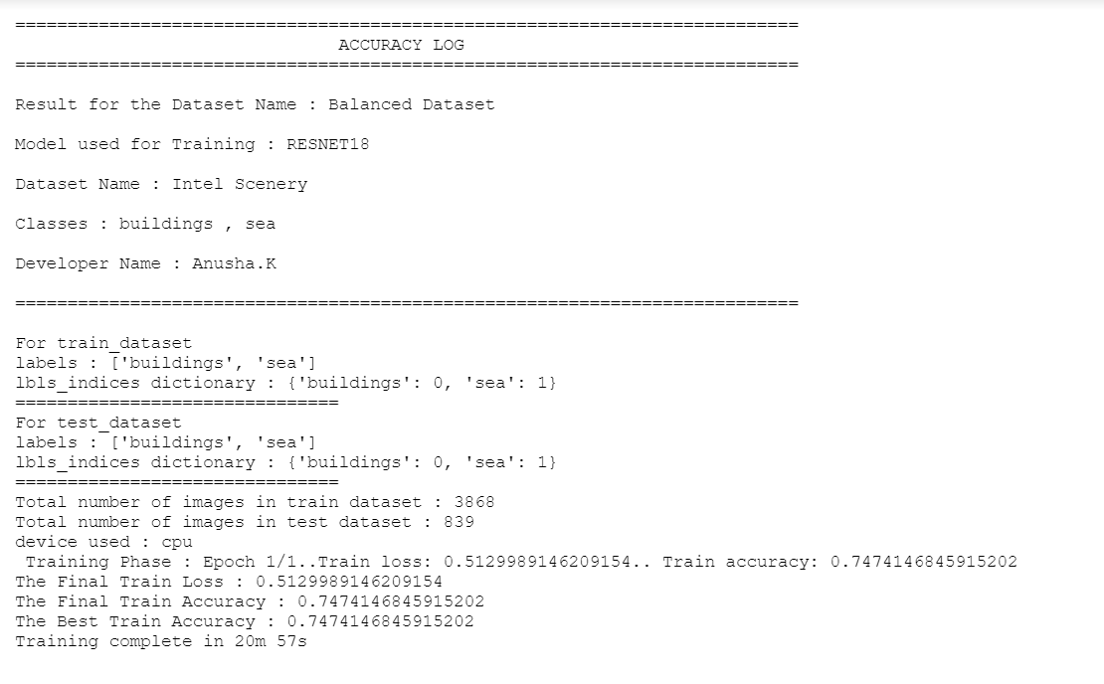

figure.25 System Diagram

|  |  |  |
| --- | --- | --- |
| Sl. No. | Type of Augmentation | Accuracies (Balanced 2:1) |
| 1 | Blur | 0.86921 |
| 2 | ChannelDropout | 0.84606 |
| 3 | CLAHE | 0.85612 |
| 4 | ChannelShuffle | 0.84837 |
| 5 | ColorJitter | 0.85532 |
| 6 | Downscale | 0.82175 |
| 7 | Emboss | 0.87152 |
| 8 | FancyPCA | 0.85416 |
| 9 | GaussNoise | 0.86111 |
| 10 | GaussianBlur | 0.83101 |
| 11 | GlassBlur | 0.86574 |
| 12 | HueSaturationValue | 0.85185 |
| 13 | ISONoise | 0.85995 |
| 14 | InvertImg | 0.86805 |
| 15 | MedianBlur | 0.8287 |
| 16 | MotionBlur | 0.84722 |
| 17 | MultiplicativeNoise | 0.84606 |
| 18 | Posterize | 0.853 |
| 19 | RGBShift | 0.86111 |
| 20 | Sharpen | 0.83912 |
| 21 | Solarize | 0.85532 |
| 22 | Superpixels | 0.8368 |
| 23 | ToGray | 0.80208 |
| 24 | ToSepia | 0.80902 |
| 25 | VerticalFlip | 0.83912 |
| 26 | HorizontalFlip | 0.85995 |
| 27 | Transpose | 0.82407 |
| 28 | OpticalDistortion | 0.85416 |
| 29 | GridDistortion | 0.84259 |
| 30 | JpegCompression | 0.84722 |
| 31 | Cutout | 0.8287 |
| 32 | CoarseDropout | 0.87615 |
| 33 | GridDropout | 0.8206 |

Table 2: Effective & Non Effective Augmentations for Intel Scene Dataset

**EFFECTIVE FINDINGS**

Augmentation techniques in improving the accuracy of the model by removing imbalance -

1. For Intel Scene Dataset -

|  |  |
| --- | --- |
| **INEFFECTIVE** | **EFFECTIVE** |
| GaussianBlur  ChannelDropout  GridDropout  Sharpen  Solarize | FancyPCA  GaussNoise  InvertImg  RGBShift  HueSaturationValue  JpegCompression  MultiplicativeNoise |

Table 2: Effective & Non Effective Augmentations for Intel Scene Dataset

|  |  |  |
| --- | --- | --- |
| **INVERSE TO IMBALANCE** | **CONSTANT TO IMBALANCE** | **DIRECT TO IMBALANCE** |
| CLAHE  Blur  CoarseDropout | Median Blur  Glass Blur  Motion Blur  To Sepia  Emboss  InvertImg  GaussNoise  RGBShift  ISONoise  HorizontalFlip  ColorJitter  OpticalDistortion  MotionBlur  MultiplicativeNoise  GridDistortion  Superpixels  Downscale  Superpixels  ToGray | Cutout  FancyPCA  Posterize  HueSaturationValue  JpegCompression  ChannelShuffle  VerticalFlip  Transpose |

Table 4: Variation of Augmentations with imbalance ratio for Intel Scene Dataset

**CONCLUSION**

**7. CONCLUSION AND RECOMMENDATION**

A. Conclusion

This project proposes an approach for solving class imbalance problems using Random Sampling and advanced data augmentation techniques. It included comparison of many augmentation libraries, and chose the best one based on various parameters, built a new Augmentation library, analyzed each type of augmentations that the library supports. We balanced the 2 classes of original datasets by developing a Dataset Balance & created an imbalance randomly by using an unbalance creator. An augmentation Dataset Creator was built that used the Augmentation library. The datasets generated are used to train the RESNET18 model with additional layers to get the accuracy metrics – train & test accuracies. The model is run for 100 epochs for each test case & choosing the best trained model using the test accuracies. This test was done for the test cases for 1:2, 1:4, 1:8, 1:16, 1:20 imbalance. The results were analyzed & compared for the various augmentation techniques & dataset. The resultant augmentations were recorded that improved the model accuracy. Data scientist & ML Engineers can use the system to improve the model to learn more with less data by implementing the effective augmentation for the datasets based on insights derived from this research

B. Future Scope

Augmentation libraries and techniques have improved a lot over the past decade with an exponential increase in data. There is a lot of research going on & few scope for future are to implement additional features such as getting the Random Transformations with the type and parameter values of it, Implementing the Random Augmentations in Augmented Dataset Creator, Getting the Accuracies for Random Augmented Datasets, implementing more cases an combination by using multiple transforms and getting the prediction scores and using the combination of the majority, moderate and lower prediction scores for the augmentation techniques. Then getting the accuracies of each for evaluation. GANs can also be implemented to create the augmented images. Data scientists & ML Engineers can use the system to improve the model to learn more with less data by implementing the effective augmentation for the datasets based on insights derived from this research with further implementation of the research in data augmentation & machine learning. This will help the customers to enhance the business etc.

**BIBLIOGRAPHY**

**8. BIBLIOGRAPHY**

[ 1 ] Mateusz Buda, Atsuto Maki, Maciej A. Mazurowski “A systematic study of the class imbalance problem in convolutional neural networks” arXiv:1710.05381v2 [cs.CV] Oct 2018

[ 2 ] Kaiming He, Xiangyu Zhang, Shaoqing Ren, Jian Sun “Deep Residual Learning for Image Recognition” arXiv:1512.03385v1 [cs.CV] Dec 2015

[ 3 ] Connor Taghi M. Khoshgoftaar “A survey on Image Data Augmentation for Deep Learning” Shorten and Khoshgoftaar J Big Data (2019)

[ 4 ] Michał Koziarski “ Radial-Based Undersampling for Imbalanced Data Classification” Michał Koziarski arXiv:1906.00452v2 [cs.LG] Apr 2021

[ 5 ] Marcus D. Bloice, Christof Stocker, Andreas Holzinger “Augmentor: An Image Augmentation Library for Machine Learning” arXiv:1708.04680v1 [cs.CV] Aug 2017

[ 6 ]. Alexandr A. Kalinin, Vladimir I. Iglovikov, Eugene Khvedchenya, Alex Parinov, Alexander Buslaev “Albumentations: fast and flexible image Augmentations” Feb 2020

[ 7 ] Hongyi Zhang, Moustapha Cisse, Yann N. Dauphin, David Lopez-Paz “MixUp augmentation for image classification”arXiv:1710.09412v2 [cs.LG] Apr 2018

[ 8 ] Zhiting Hu, Bowen Tan, Ruslan Salakhutdinov, Tom Mitchell, Eric P. Xing “Learning Data Manipulation for Augmentation and Weighting “ arXiv:1910.12795v1 [cs.LG] Oct 2019

[ 9 ] Shanchuan Lin, Linjie Yang, Imran Saleemi, Soumyadip Sengupta “Robust High-Resolution Video Matting with Temporal Guidance” arXiv:2108.11515v1 [cs.CV] Aug 2021

[ 10 ] Xu Sun, Huihui Fang, Yehui Yang, Dongwei Zhu, Lei Wang, Junwei Liu, Yanwu Xu “Robust Retinal Vessel Segmentation from a Data Augmentation Perspective” arXiv:2007.15883v2 [eess.IV] Sep 2021

[ 11 ] Wanwan Zheng, Mingzhe Jin “The Effects of Class Imbalance and Training Data Size on Classifier Learning” Springer Feb 2020

[ 12 ] Alex Krizhevsky, Ilya Sutskever, Geoffrey E. Hinton “ImageNet Classification with Deep Convolutional Neural Networks “ NeurIPS Proceedings 2012

[ 13 ] Ian J. Goodfellow, Jean Pouget-Abadie, Mehdi Mirza, Bing Xu, David Warde-Farley, Sherjil Ozair, Aaron Courville, Yoshua Bengio “Generative Adversarial Networks “ arXiv:1406.2661v1 [stat.ML] Jun 2014

[ 14 ] N. V. Chawla, K. W. Bowyer, L. O. Hall, W. P. Kegelmeyer “SMOTE: Synthetic Minority Over-sampling Technique” Journal of Artificial Intelligence Research 16 (2002)

[ 15 ] Elena Limonova, Daniil Alfonso, Dmitry Nikolaev, Vladimir V. Arlazarov “ResNet-like Architecture with Low Hardware Requirements” arXiv:2009.07190v2 [cs.CV] Oct 2020